- Introduction to SQL

Lab 3: Create a database called library_db and a table books with columns: book_id, title, author, publisher, year_of_publication, and price. Insert five records into the table.
Ans. CREATE DATABASE library_db;
USE library_db;
CREATE TABLE books ( book_id INT PRIMARY KEY, title VARCHAR(100), author VARCHAR(100), publisher VARCHAR(100),year_of_publication INT,
price DECIMAL(8,2));
INSERT INTO books (book_id, title, author, publisher, year_of_publication, price)
VALUES
(1, 'The Alchemist', 'Paulo Coelho', 'HarperCollins', 1988, 350.00),
(2, 'Rich Dad Poor Dad', 'Robert Kiyosaki', 'Plata Publishing', 1997, 450.00),
(3, 'Think and Grow Rich', 'Napoleon Hill', 'The Ralston Society', 1937, 300.00),
(4, 'Wings of Fire', 'A.P.J. Abdul Kalam', 'Universities Press', 1999, 280.00),
(5, 'The Power of Positive Thinking', 'Norman Vincent Peale', 'Prentice Hall', 1952, 320.00);
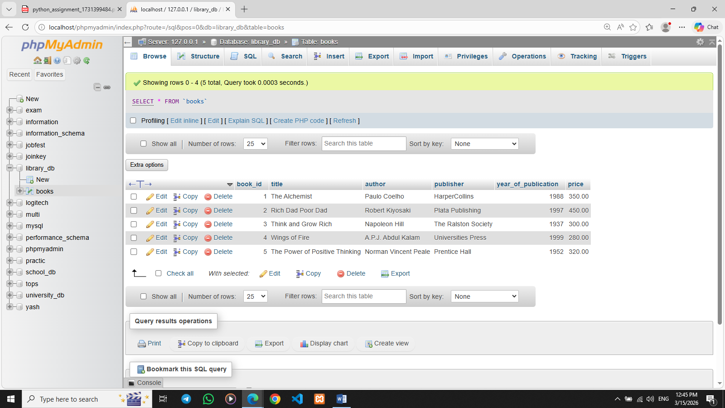

Lab 4: Create a table members in library_db with columns: member_id, member_name, date_of_membership, and email. Insert five records into this table.
Ans. CREATE TABLE members ( member_id INT PRIMARY KEY,member_name VARCHAR(100),date_of_membership DATE,email VARCHAR(100));
INSERT INTO members (member_id, member_name, date_of_membership, email)
VALUES
(1, 'Yash Ahiya', '2023-01-15', 'yash@gmail.com'),
(2, 'Mohit Thakkar', '2023-03-20', 'mohit@gmail.com'),
(3, 'Chirag Khimsuriya', '2023-05-10', 'chirag@gmail.com'),
(4, 'Darshan Davera', '2023-07-25', 'darshan@gmail.com'),
(5, 'Harsh Toliya', '2023-09-05', 'harsh@gmail.com');

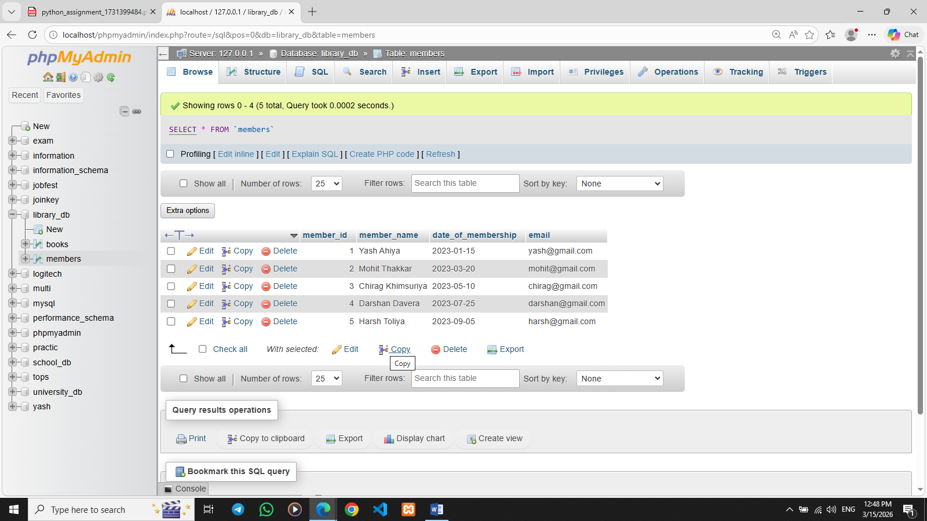

- SQL Syntax

Lab 3: Retrieve all members who joined the library before 2022. Use appropriate SQL syntax with WHERE and ORDER BY.
Ans. SELECT *FROM members WHERE date_of_membership < '2022-01-01'ORDER BY date_of_membership;
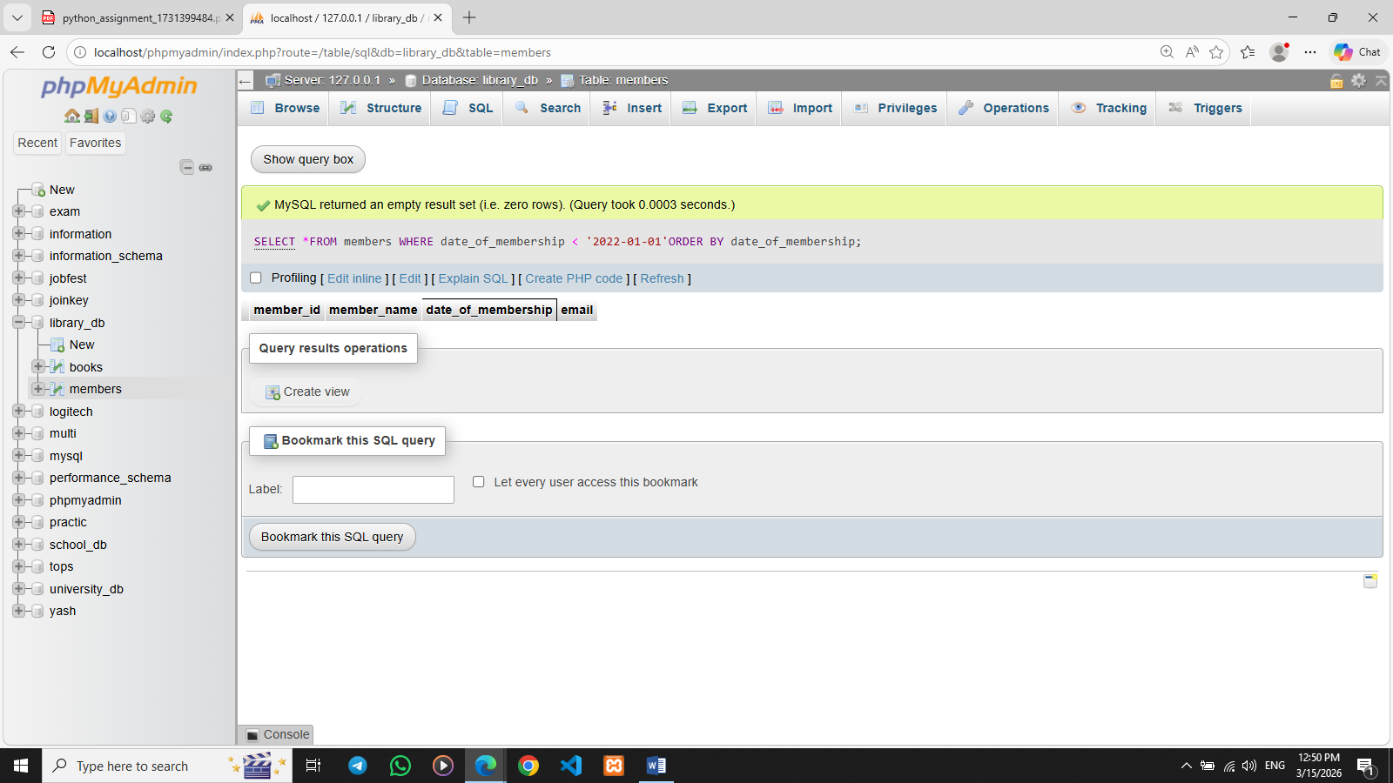

Lab 4: Write SQL queries to display the titles of books published by a specific author. Sort the results by year_of_publication in descending order.
Ans. SELECT title FROM books WHERE author = 'Paulo Coelho' ORDER BY year_of_publication DESC;
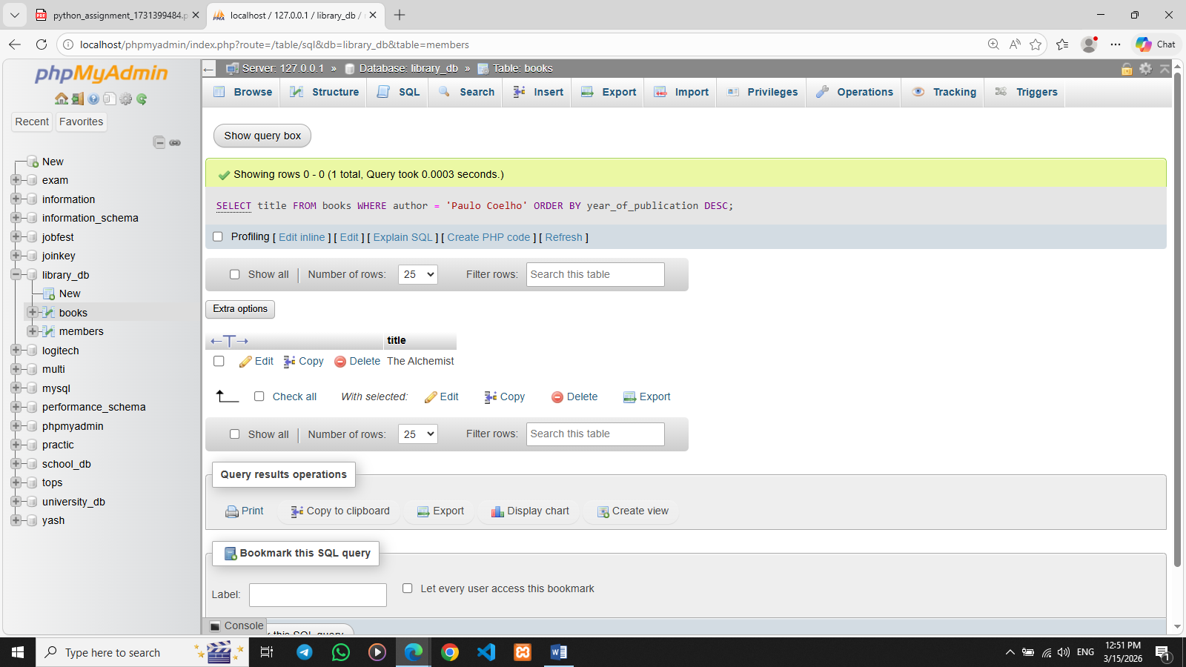

- SQL Constraints

Lab 3: Add a CHECK constraint to ensure that the price of books in the books table is greater than 0.
Ans. ALTER TABLE books ADD CONSTRAINT chk_price CHECK (price > 0);
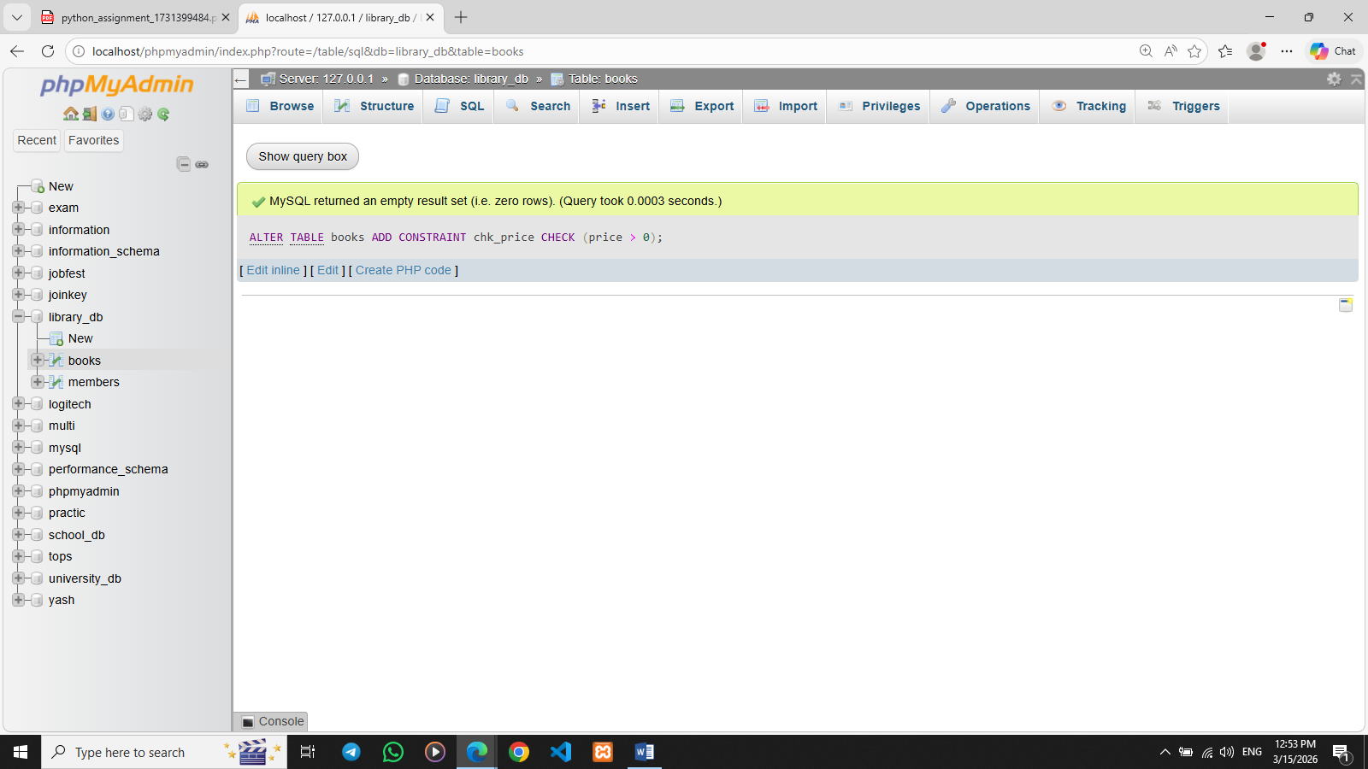

Lab 4: Modify the members table to add a UNIQUE constraint on the email column, ensuring that each member has a unique email address.
Ans. ALTER TABLE members ADD CONSTRAINT unique_email UNIQUE (email);
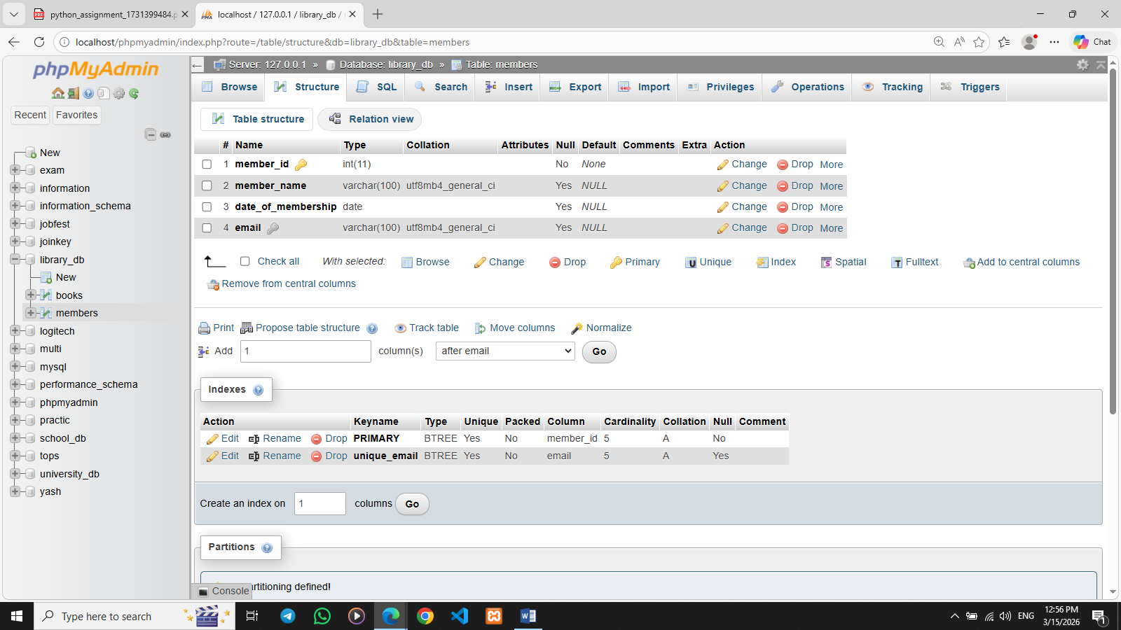

- Main SQL Commands and Sub-commands (DDL)

Lab 3: Create a table authors with the following columns: author_id, first_name, last_name, and country. Set author_id as the primary key.
Ans. CREATE TABLE authors (author_id INT PRIMARY KEY,first_name VARCHAR(50),last_name VARCHAR(50),country VARCHAR(50));
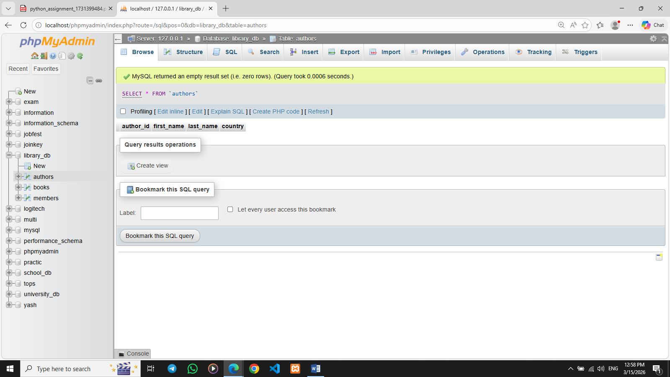
Lab 4: Create a table publishers with columns: publisher_id, publisher_name, contact_number, and address. Set publisher_id as the primary key and contact_number as unique.
Ans. CREATE TABLE publishers (publisher_id INT PRIMARY KEY,publisher_name VARCHAR(100),contact_number VARCHAR(15) UNIQUE,address VARCHAR(150));
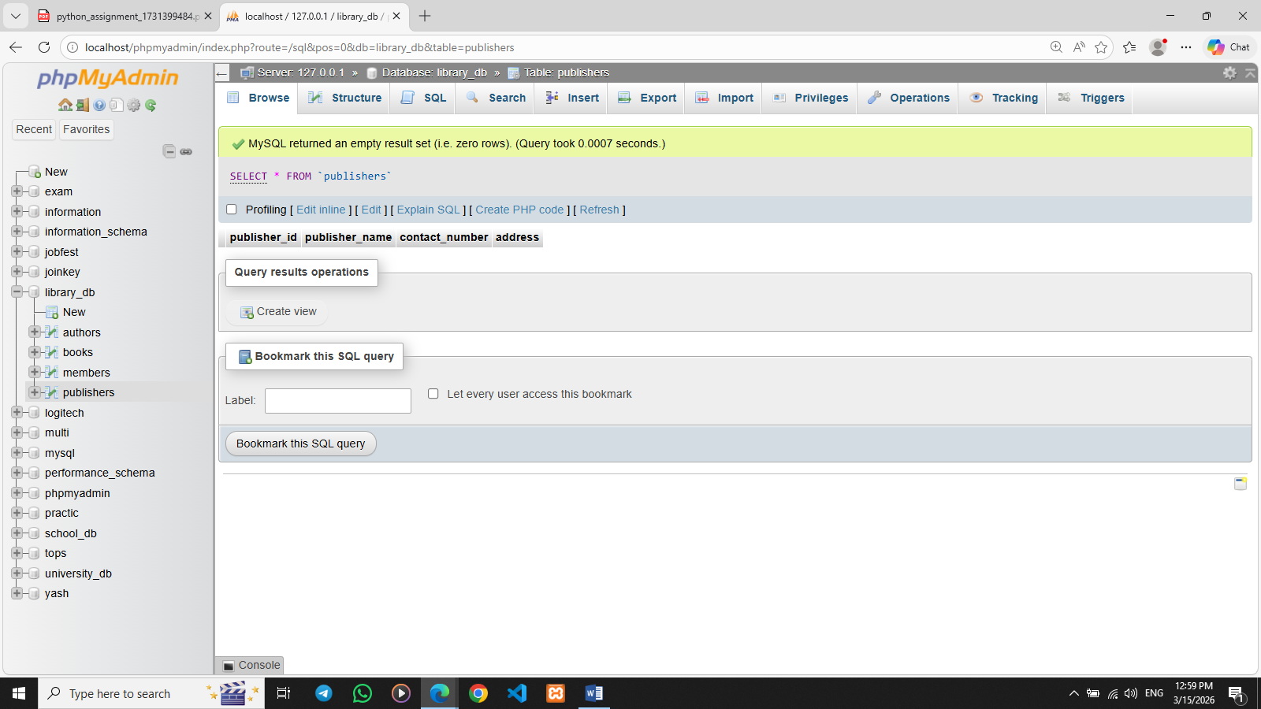

- ALTER Command

Lab 3: Add a new column genre to the books table. Update the genre for all existing records.
Ans. ALTER TABLE books ADD genre VARCHAR(50);UPDATE books SET genre = 'Fiction' WHERE book_id = 1;
UPDATE books SET genre = 'Finance' WHERE book_id = 2;
UPDATE books SET genre = 'Self-Help' WHERE book_id = 3;
UPDATE books SET genre = 'Autobiography' WHERE book_id = 4;
UPDATE books SET genre = 'Motivational' WHERE book_id = 5;
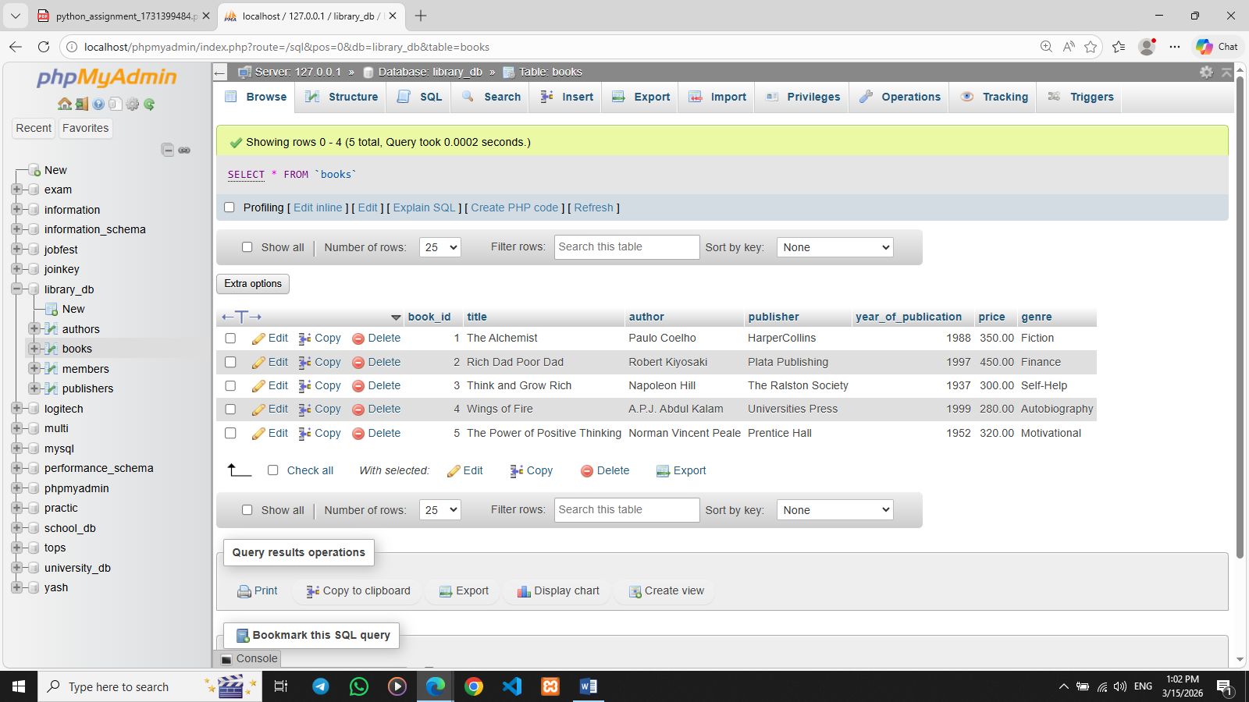

Lab 4: Modify the members table to increase the length of the email column to 100 characters.
Ans. ALTER TABLE members MODIFY email VARCHAR(100);
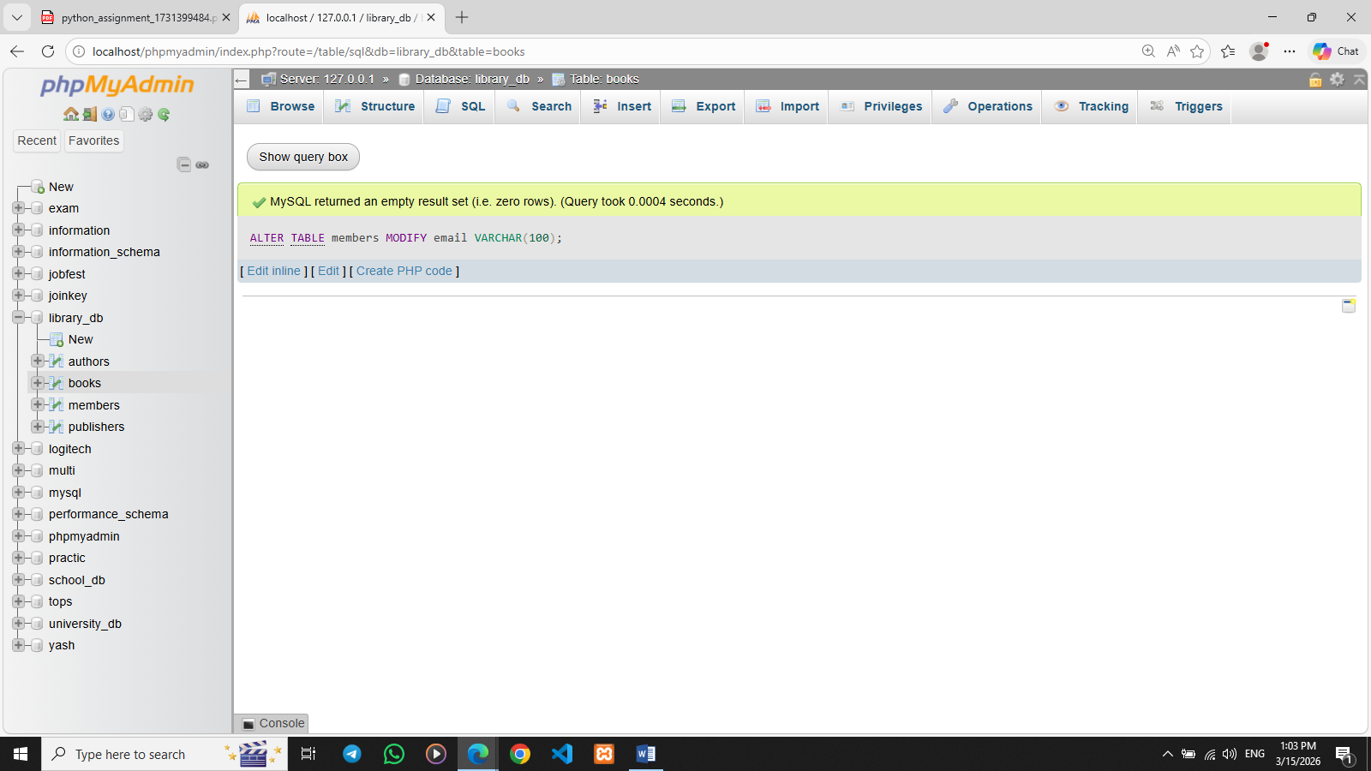

- DROP Command

Lab 3: Drop the publishers table from the database after verifying its structure.
Ans. DESCRIBE publishers;
SHOW COLUMNS FROM publishers;
DROP TABLE publishers;
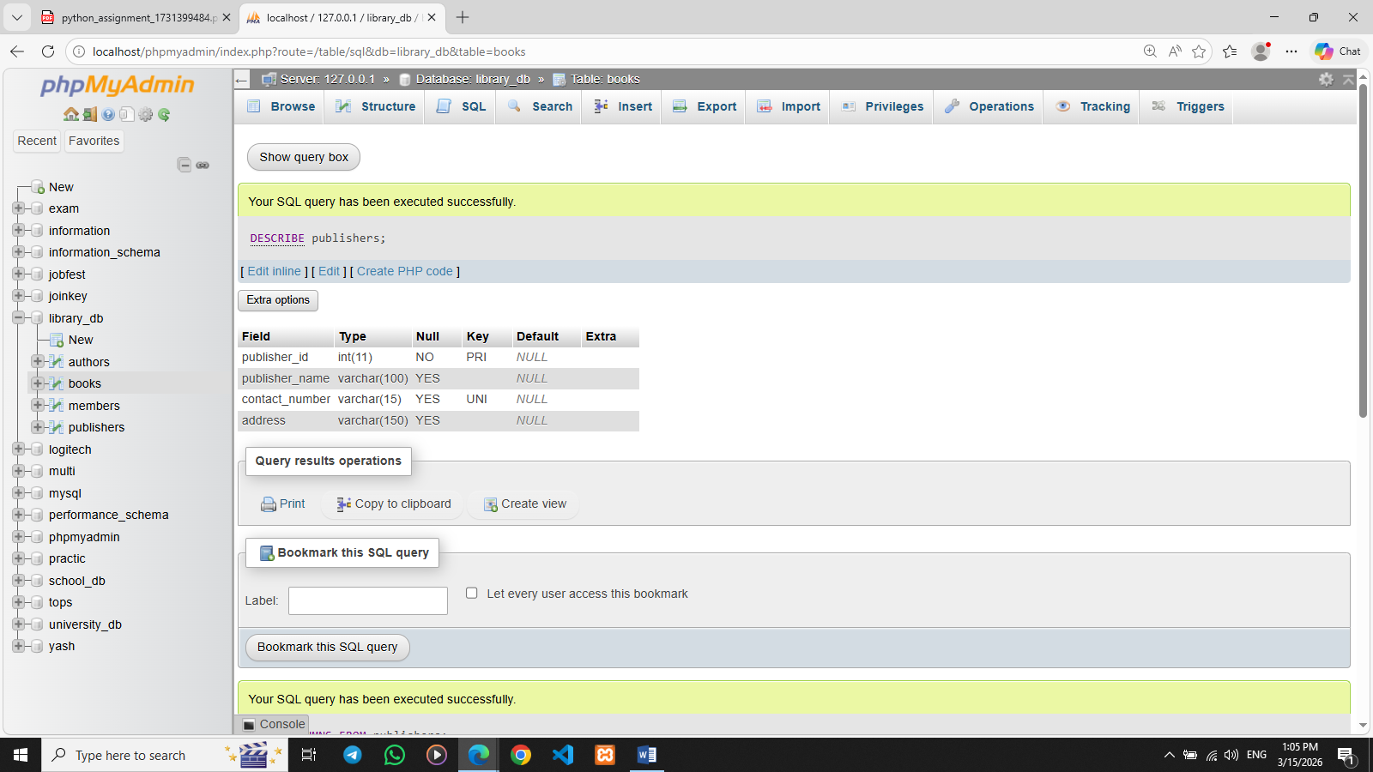

Lab 4: Create a backup of the members table and then drop the original members table.
Ans. CREATE TABLE members_backup AS SELECT * FROM members;
SELECT * FROM members_backup;
DROP TABLE members;
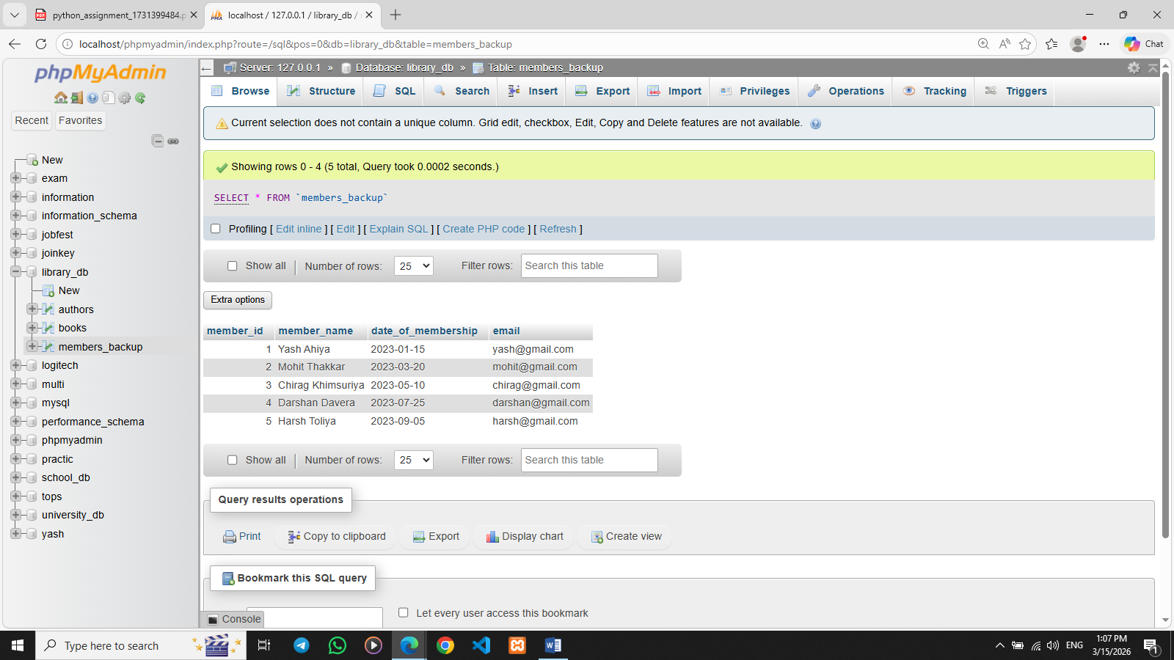
- Data Manipulation Language (DML)

Lab 4: Insert three new authors into the authors table, then update the last name of one of the authors.
Ans. INSERT INTO authors (author_id, first_name, last_name, country)VALUES(1, 'Paulo', 'Coelho', 'Brazil'),(2, 'Robert', 'Kiyosaki', 'USA'),(3, 'Napoleon', 'Hill', 'USA');
UPDATE authors SET last_name = 'Hills' WHERE author_id = 3;
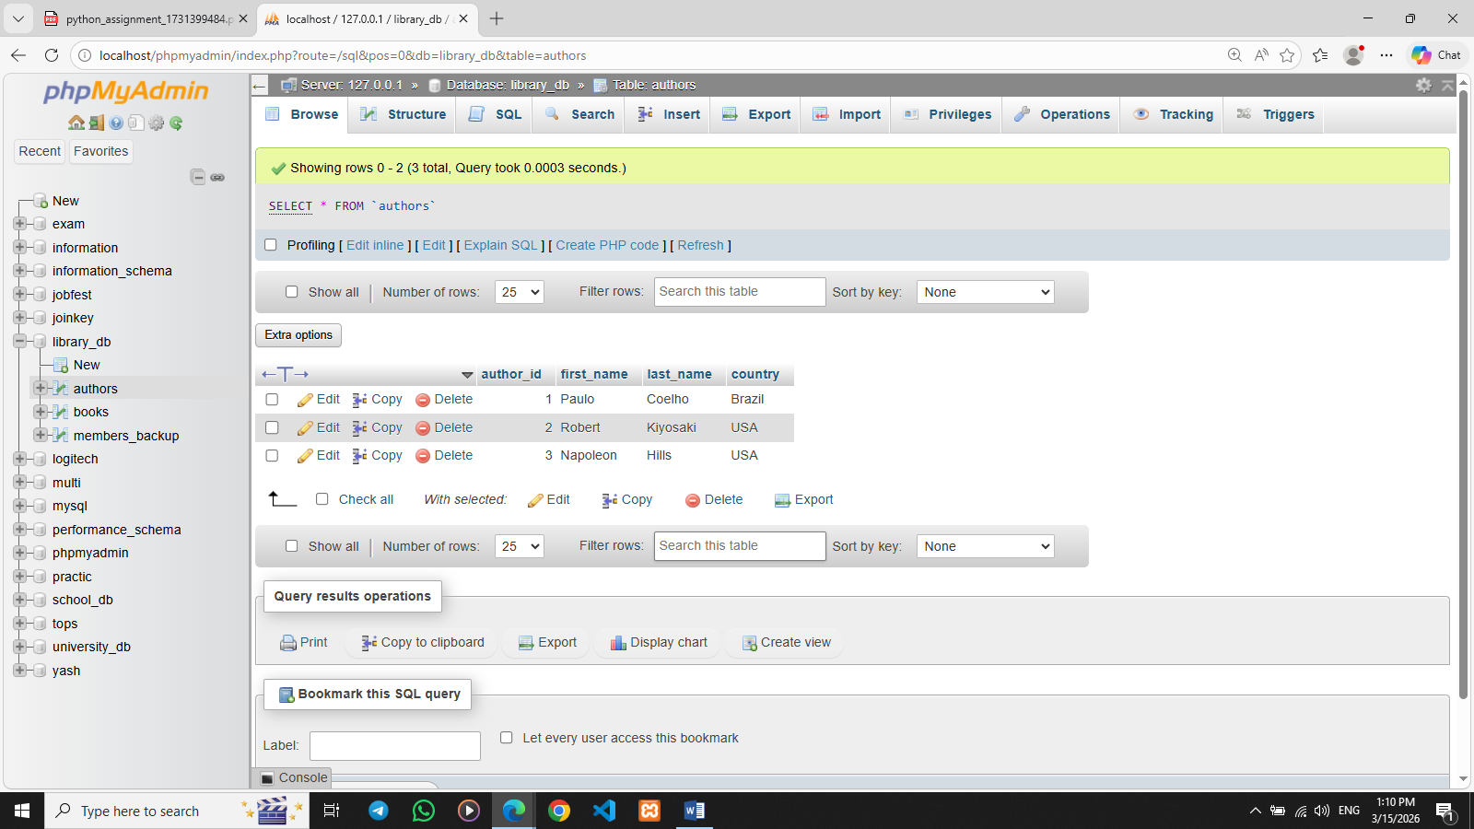

Lab 5: Delete a book from the books table where the price is higher than $100.
Ans. DELETE FROM books WHERE price > 100;
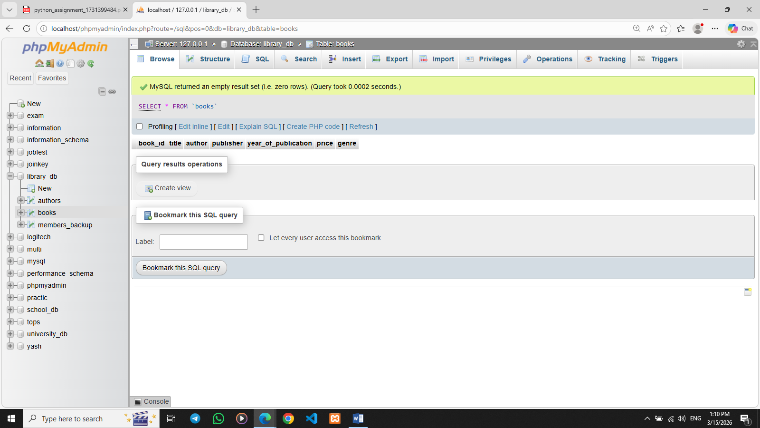

- UPDATE Command

Lab 3: Update the year_of_publication of a book with a specific book_id.
Ans. UPDATE books SET year_of_publication = 2005 WHERE book_id = 1;
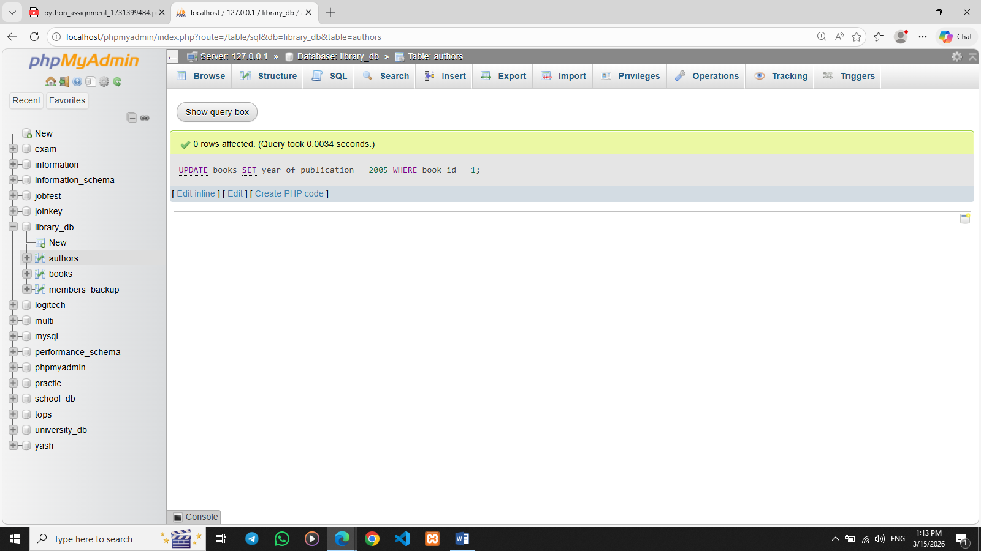

Lab 4: Increase the price of all books published before 2015 by 10%.
Ans. UPDATE books SET price = price * 1.10 WHERE year_of_publication < 2015;
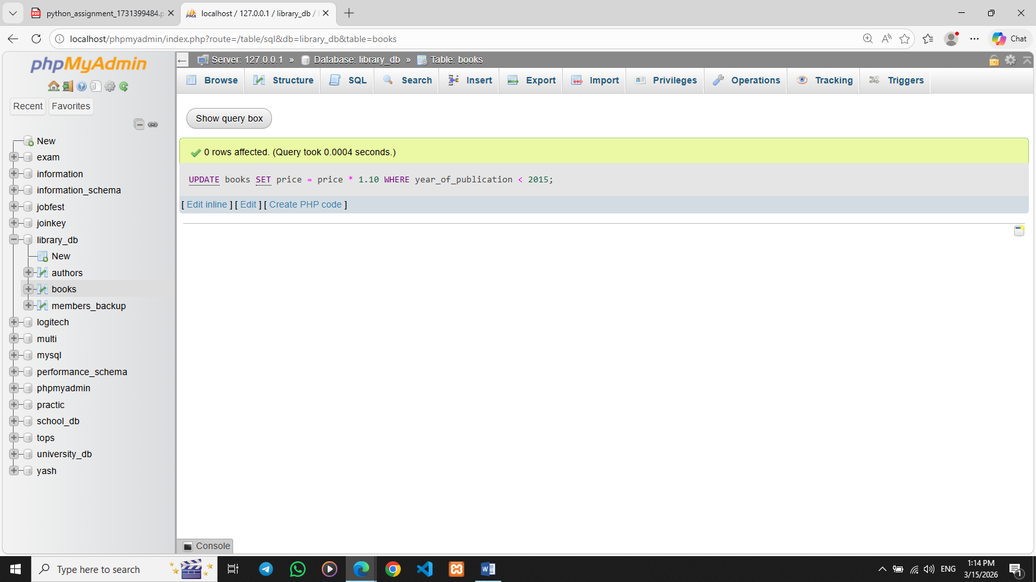

- DELETE Command

Lab 3: Remove all members who joined before 2020 from the members table.
Ans. DELETE FROM members_backup WHERE date_of_membership < '2020-01-01';

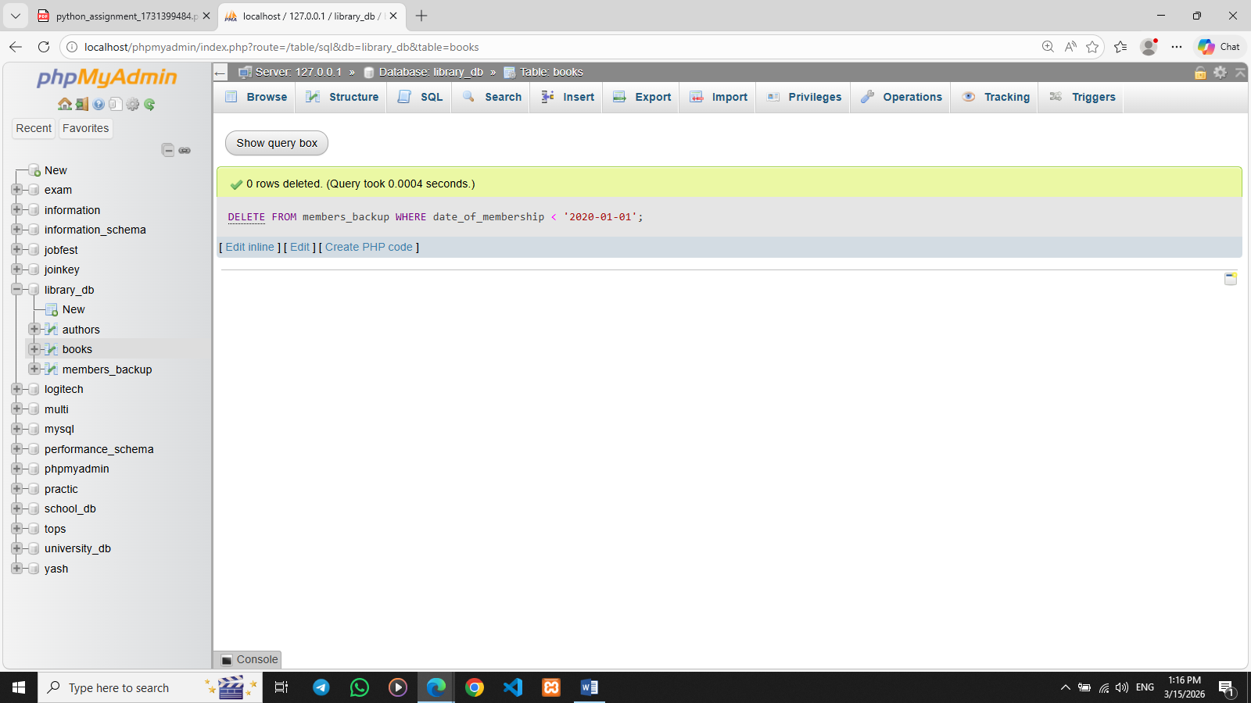

Lab 4: Delete all books that have a NULL value in the author column.
Ans. DELETE FROM books WHERE author IS NULL;
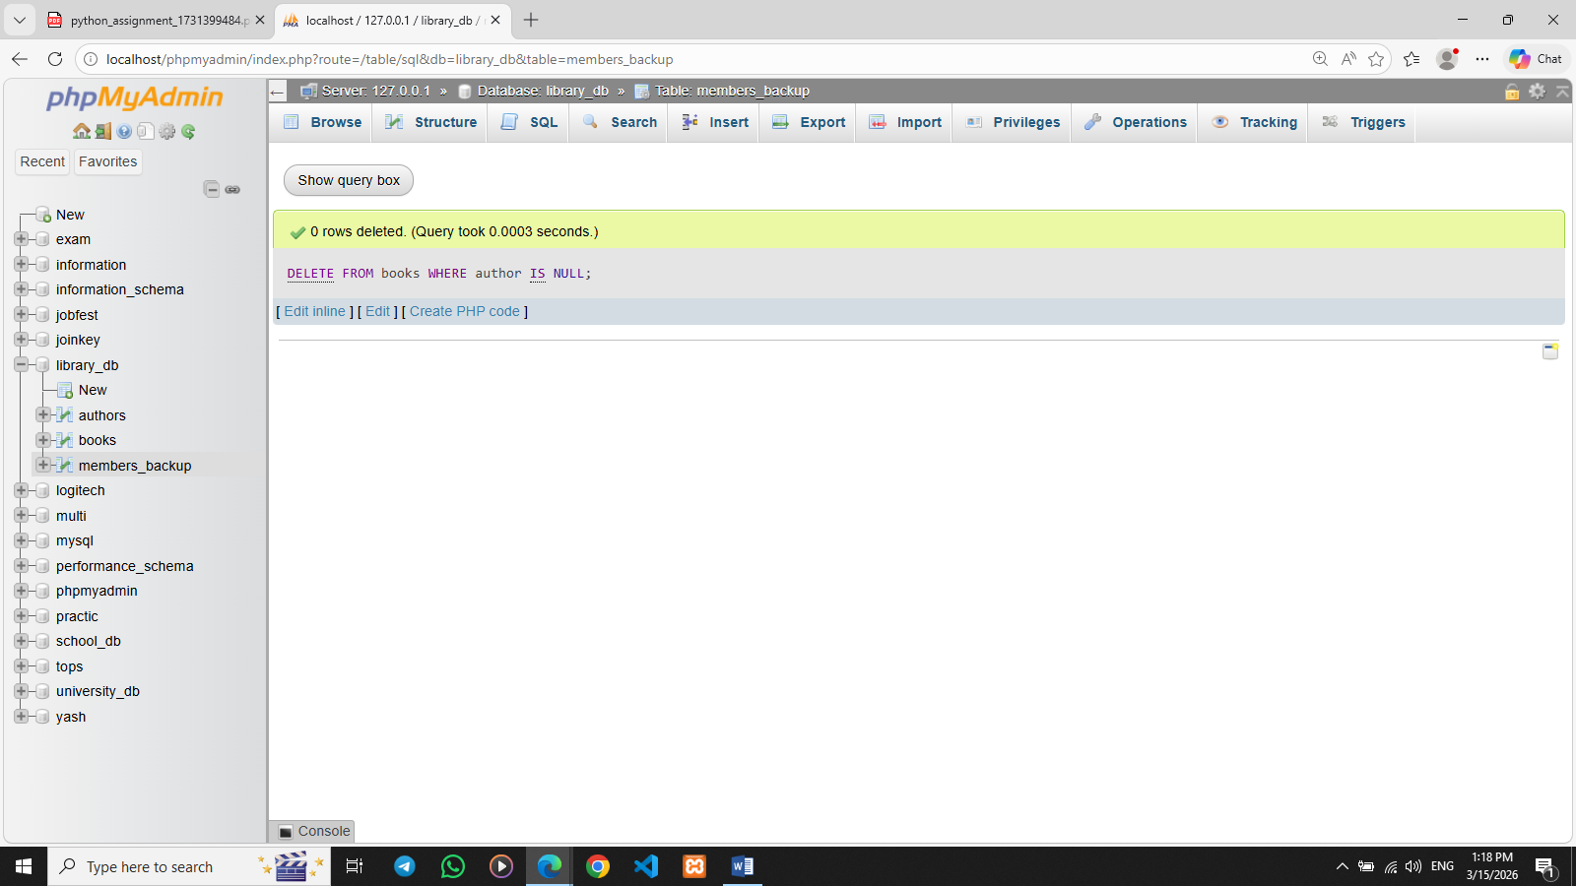

- Data Query Language (DQL)

Lab 4: Write a query to retrieve all books with price between $50 and $100.
Ans. SELECT * FROM Books WHERE Price BETWEEN 50 AND 100
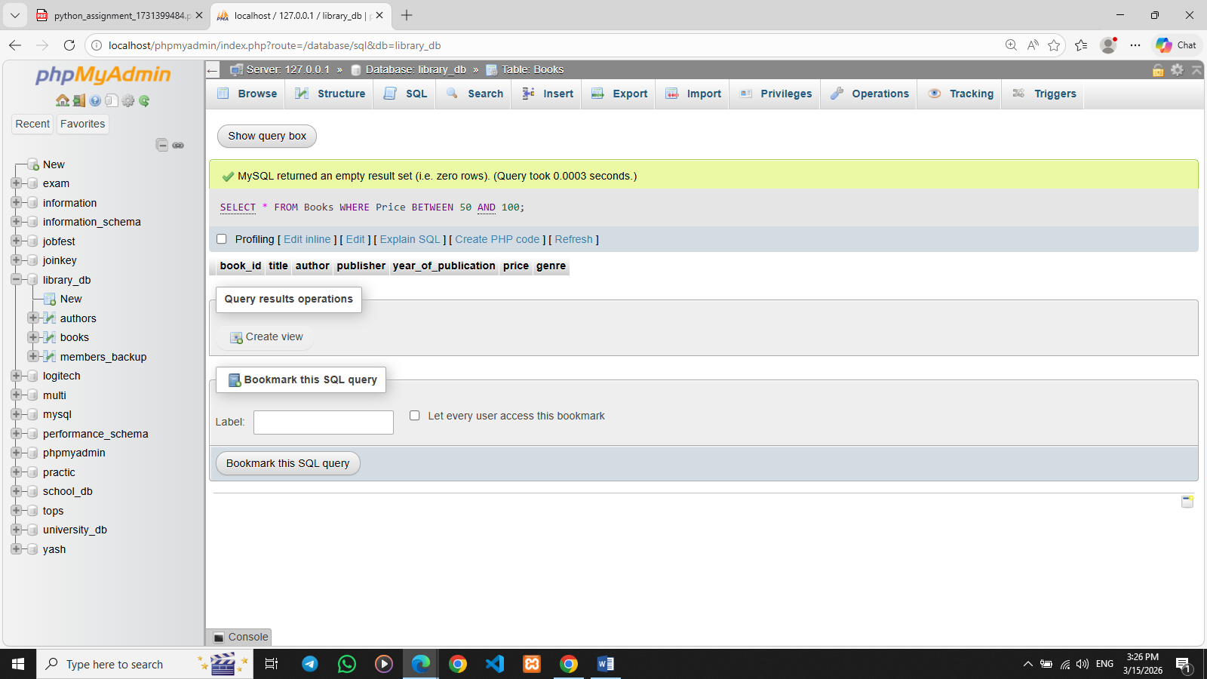

Lab 5: Retrieve the list of books sorted by author in ascending order and limit the results to the top 3 entries.
Ans. SELECT * FROM Books ORDER BY Author ASC LIMIT 3;
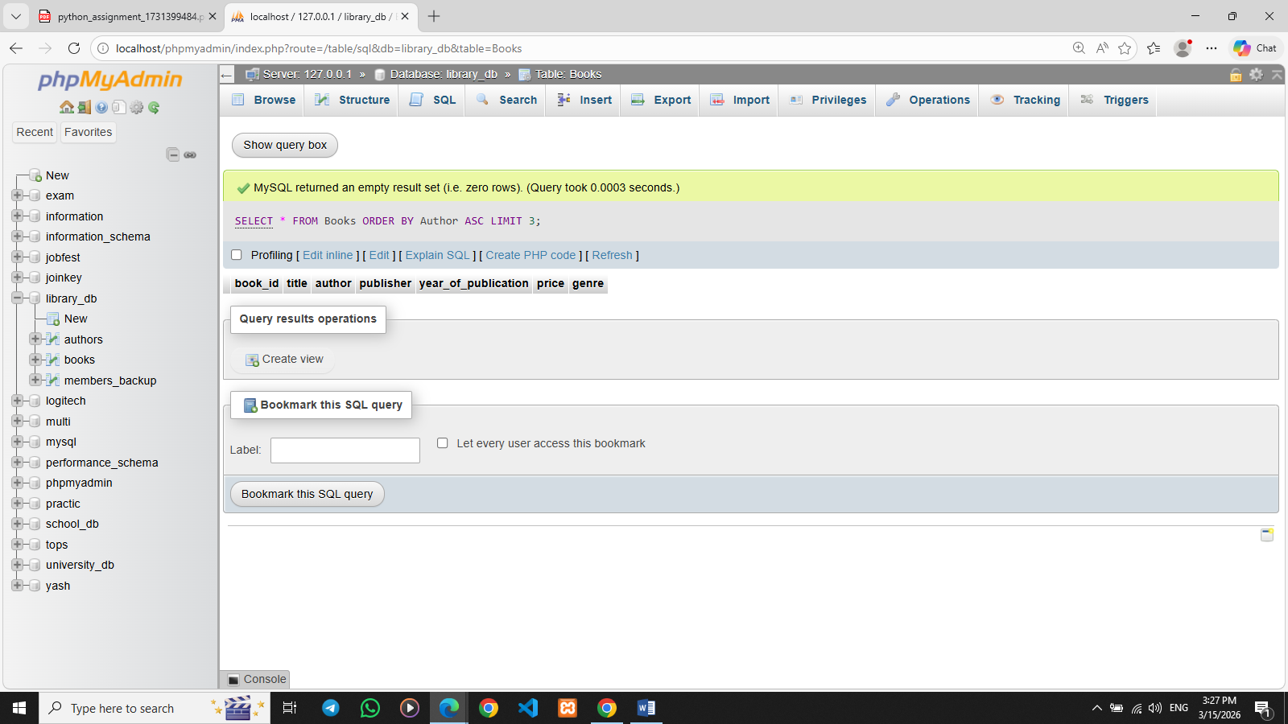

11.Data Control Language (DCL)

Lab 3: Grant SELECT permission to a user named librarian on the books table.
Ans. GRANT SELECT ON Books TO librarian;
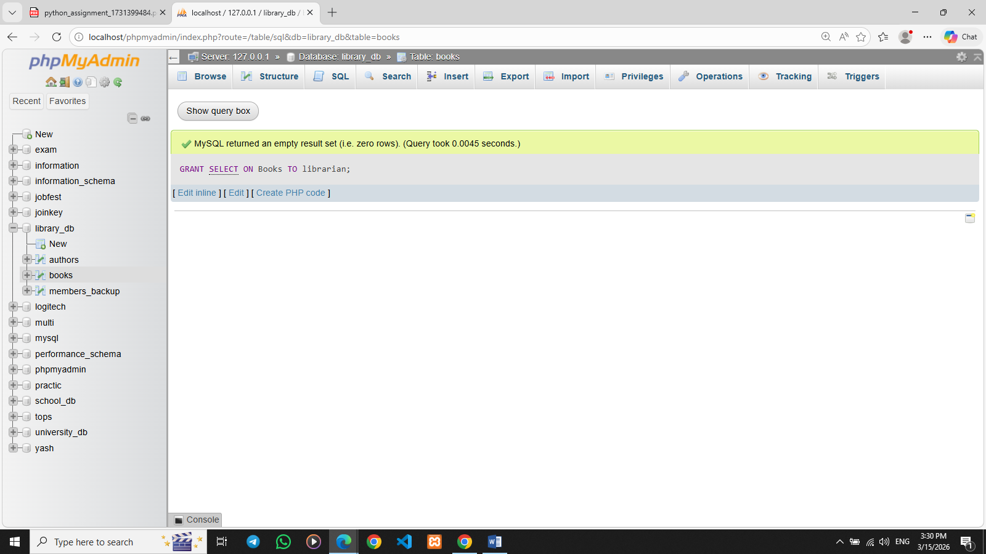

Lab 4: Grant INSERT and UPDATE permissions to the user admin on the members table.
Ans. GRANT INSERT, UPDATE ON members_backup TO admin;
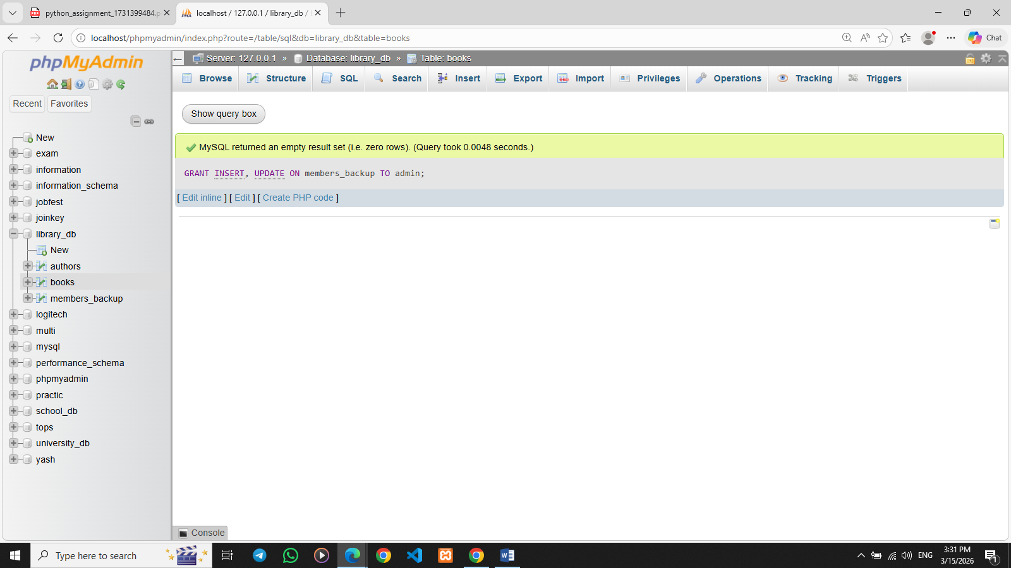
- REVOKE Command

Lab 3: Revoke the INSERT privilege from the user librarian on the books table.
Ans. REVOKE INSERT ON Books FROM librarian;
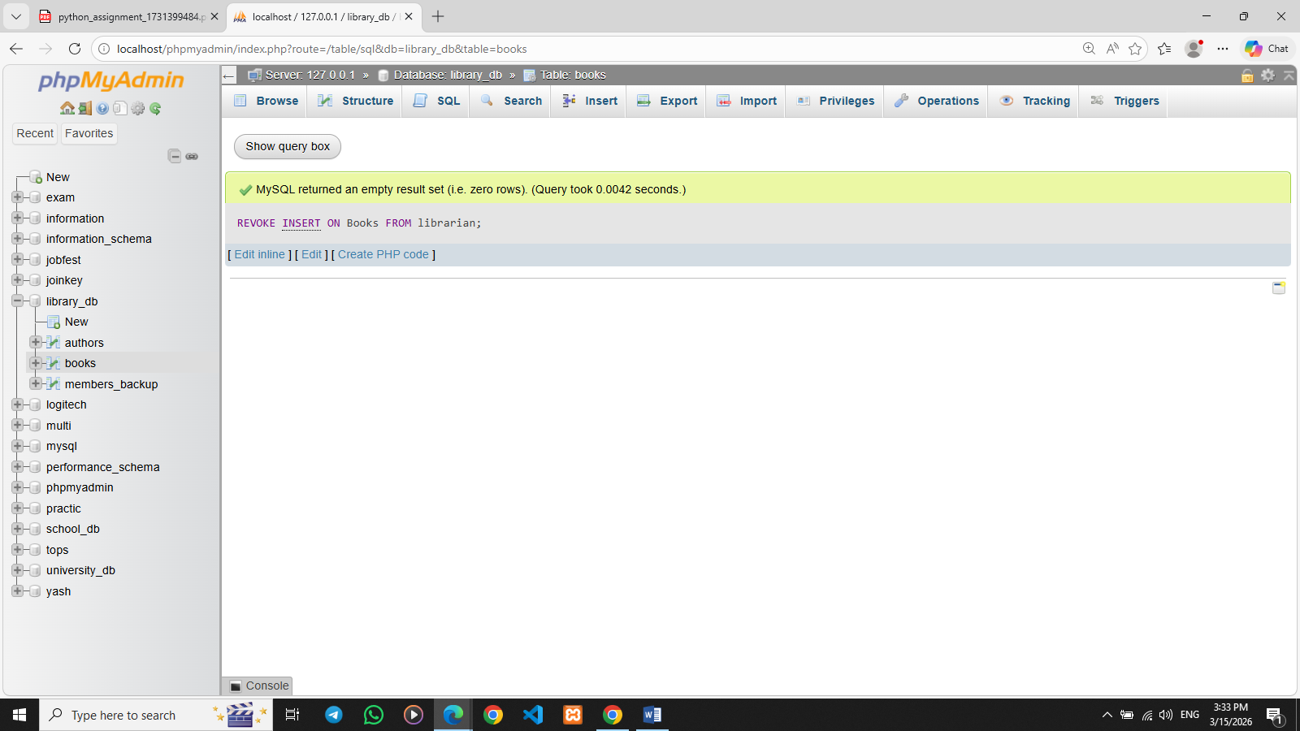

Lab 4: Revoke all permissions from user admin on the members table.
Ans. REVOKE ALL PRIVILEGES ON Members FROM admin;


- Transaction Control Language (TCL)

Lab 3: Use COMMIT after inserting multiple records into the books table, then make another insertion and perform a ROLLBACK.
Ans. INSERT INTO Books (book_id, Title, Author, Price)VALUES (1, 'Database Systems', 'Navathe', 60);

INSERT INTO Books (book_id, Title, Author, Price)VALUES (2, 'SQL Basics', 'John Smith', 55);

COMMIT;

INSERT INTO Books (book_id, Title, Author, Price)VALUES (3, 'Advanced SQL', 'Jane Doe', 75);

ROLLBACK;

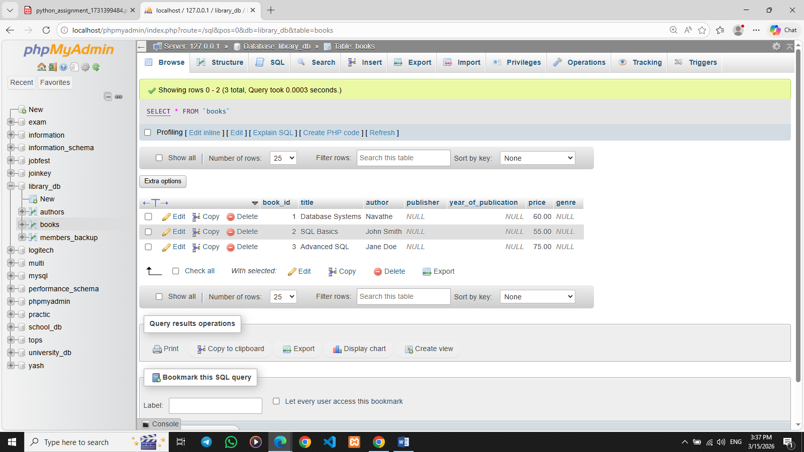

- SQL Joins

Lab 3: Perform an INNER JOIN between books and authors tables to display the title of books and their respective authors' names.
Ans. SELECT Books.Title, Authors.first_name FROM Books INNER JOIN Authors ON Books.Author = Authors.author_id;
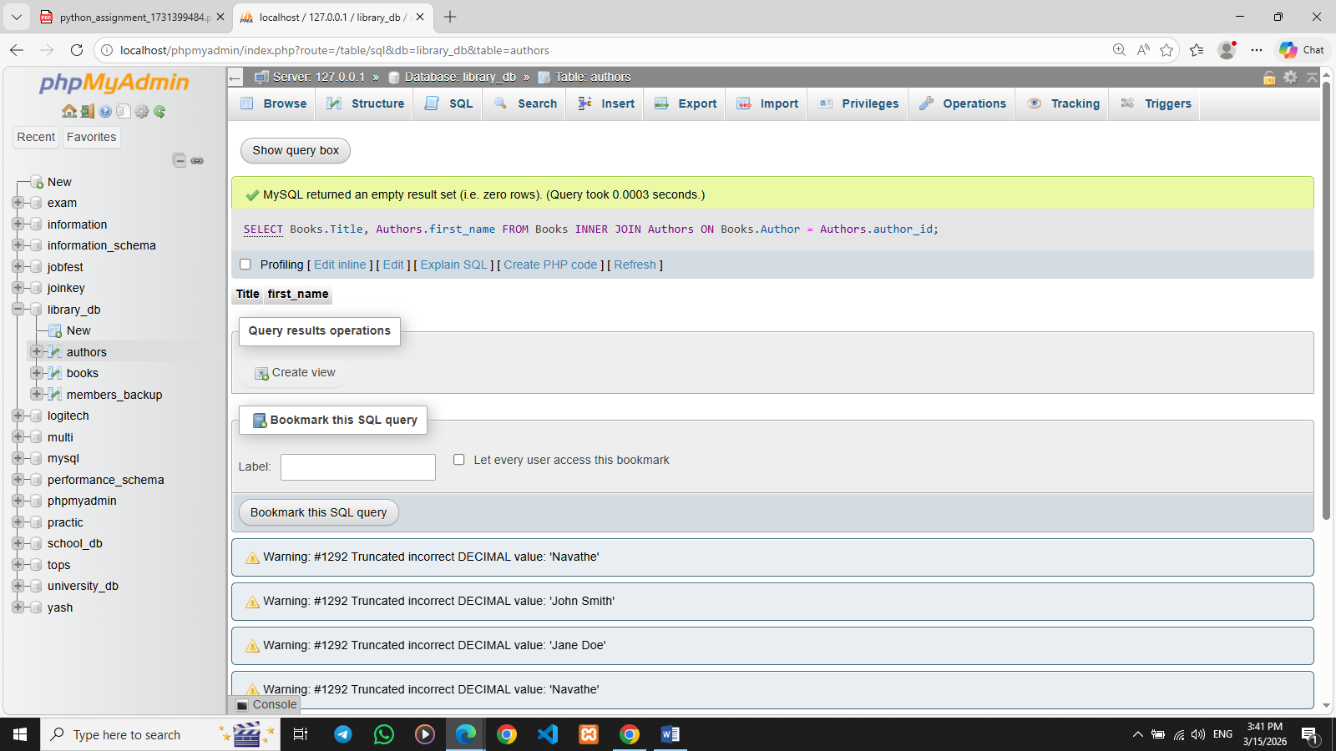

Lab 4: Use a FULL OUTER JOIN to retrieve all records from the books and authors tables, including those with no matching entries in the other table.
Ans. SELECT books.title, authors.first_name, authors.last_name
FROM books
INNER JOIN authors
ON books.author = CONCAT(authors.first_name, ' ', authors.last_name);
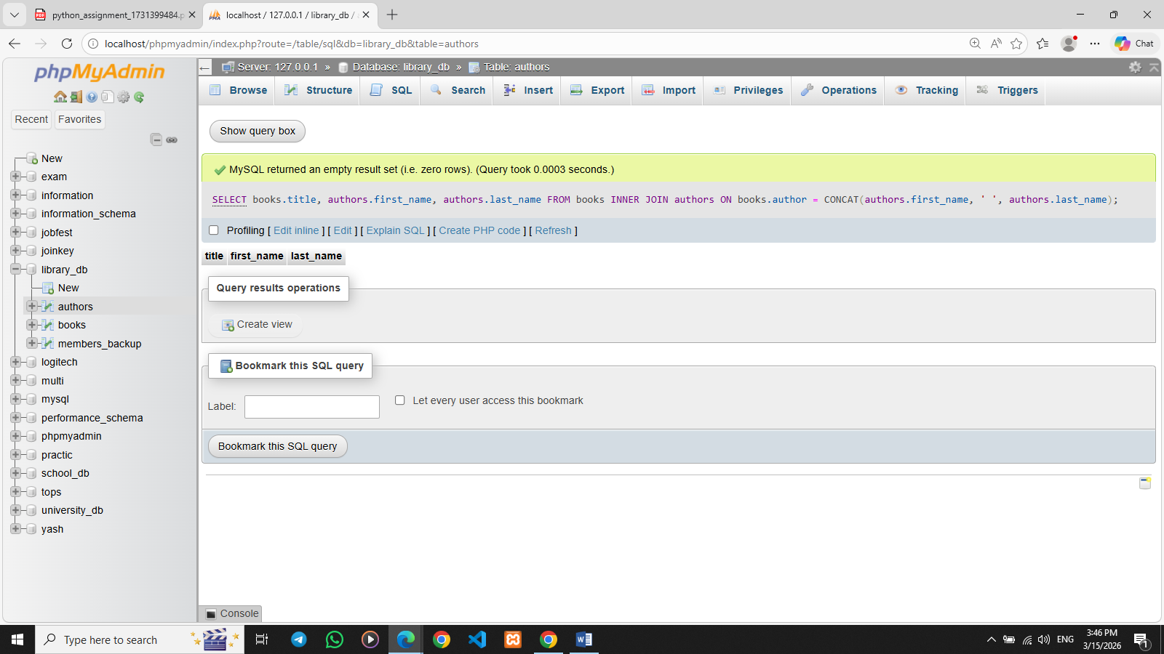

- SQL Group By

Lab 3: Group books by genre and display the total number of books in each genre.
Ans. SELECT genre, COUNT(*) AS total_books FROM books GROUP BY genre;
SELECT genre, COUNT(*) AS total_books
FROM books
GROUP BY genre;

Lab 4: Group members by the year they joined and find the number of members who joined each year.
Ans. SELECT YEAR(date_of_membership) AS join_year, COUNT(*) AS total_members FROM members_backup GROUP BY YEAR(date_of_membership);
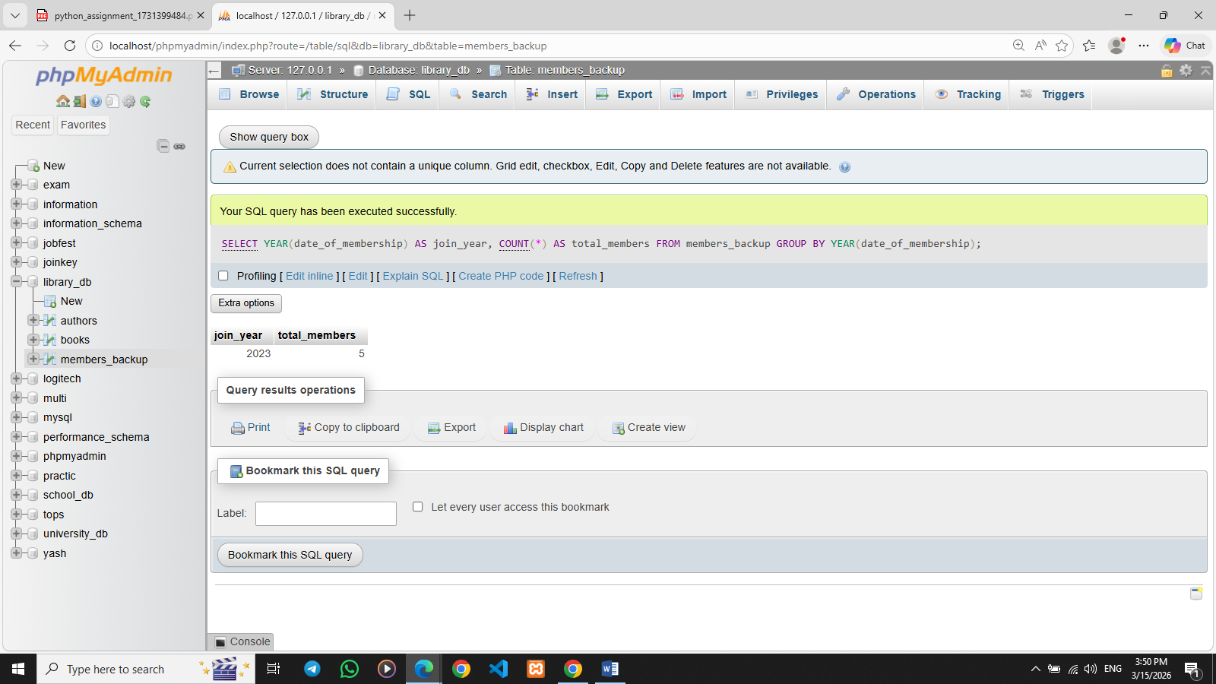

- SQL Stored Procedure

Lab 3: Write a stored procedure to retrieve all books by a particular author.
Ans. DELIMITER //

CREATE PROCEDURE GetBooksByAuthor(IN author_name VARCHAR(100))
BEGIN
SELECT *
FROM books
WHERE author = author_name;
END //

DELIMITER ;

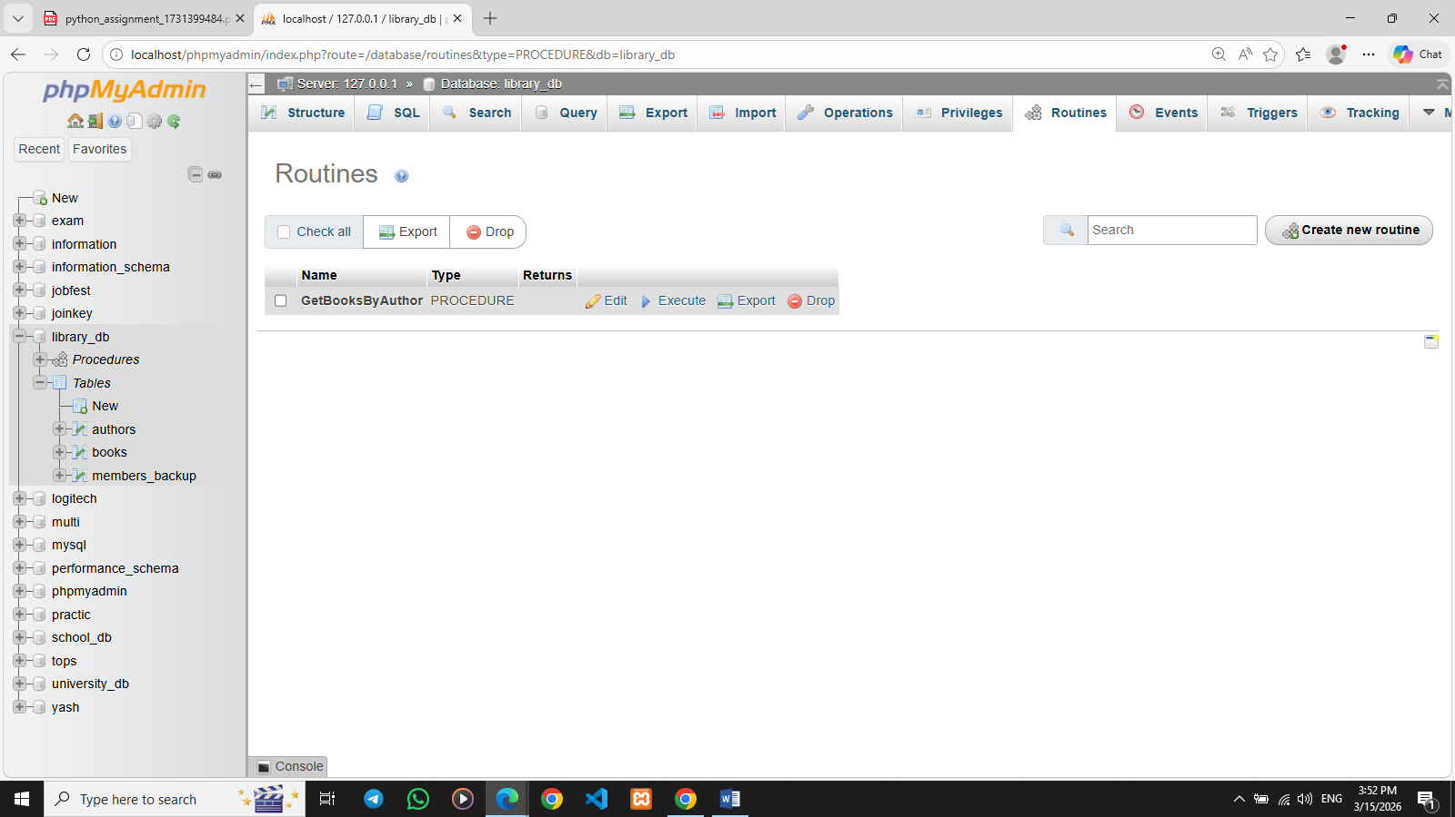

Lab 4: Write a stored procedure that takes book_id as an argument and returns the price of the book.
Ans. DELIMITER //
CREATE PROCEDURE GetBookPrice(IN b_id INT)
BEGIN
SELECT price
FROM books
WHERE book_id = b_id;
END //
DELIMITER ;

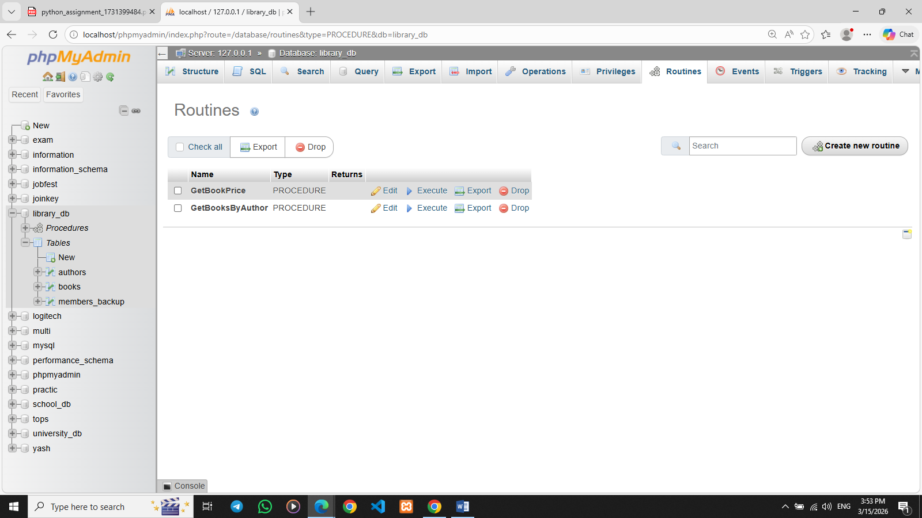

- SQL View

Lab 3: Create a view to show only the title, author, and price of books from the books table.
Ans. CREATE VIEW book_details AS SELECT title, author, price FROM books;
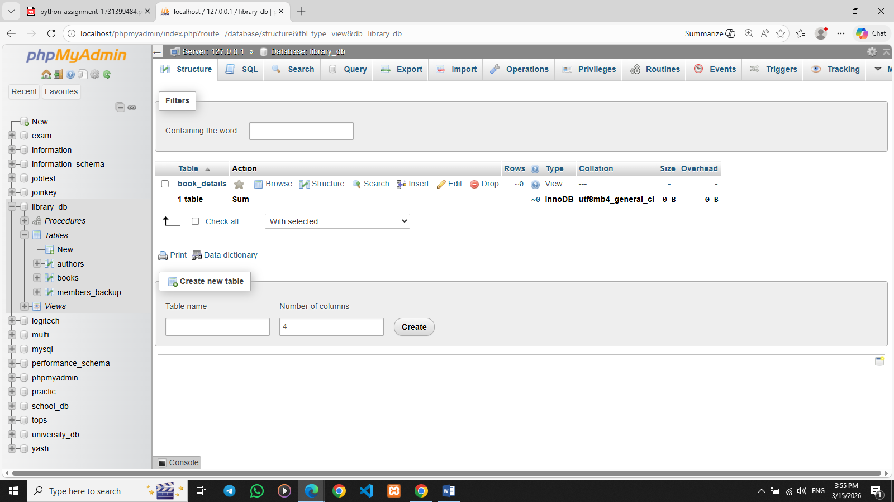

Lab 4: Create a view to display members who joined before 2020.
Ans. CREATE VIEW members_before_2020 AS SELECT * FROM members_backup WHERE YEAR(date_of_membership) < 2020;
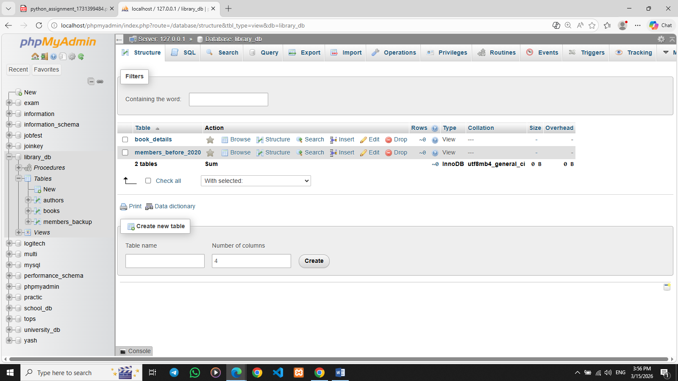

- SQL Trigger

Lab 3: Create a trigger to automatically update the last_modified timestamp of the books table whenever a record is updated.
Ans. DELIMITER //

CREATE TRIGGER update_last_modified
BEFORE UPDATE ON books
FOR EACH ROW
BEGIN
SET NEW.last_modified = CURRENT_TIMESTAMP;
END //

DELIMITER ;
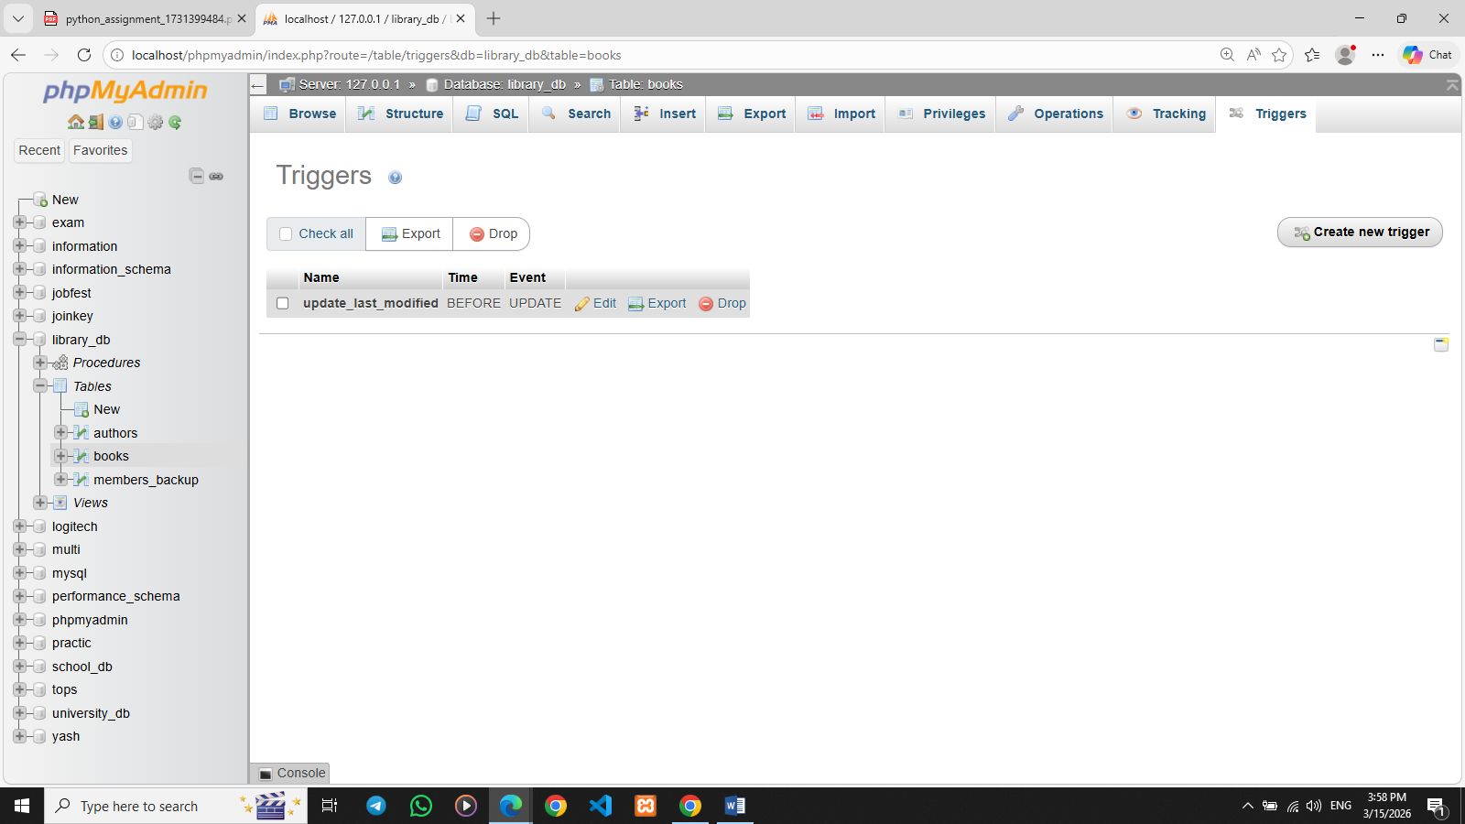

Lab 4: Create a trigger that inserts a log entry into a log_changes table whenever a DELETE operation is performed on the books table.
Ans. DELIMITER //

CREATE TRIGGER log_book_delete
AFTER DELETE ON books
FOR EACH ROW
BEGIN
INSERT INTO log_changes(book_id, action_type)
VALUES (OLD.book_id, 'DELETE');
END //

DELIMITER ;
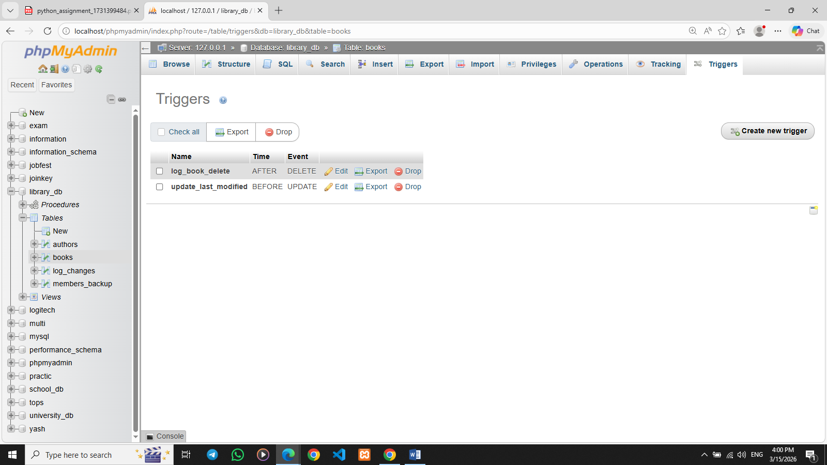

- Introduction to PL/SQL

Lab 3: Write a PL/SQL block to insert a new book into the books table and display a confirmation message.
Ans. DELIMITER //

CREATE PROCEDURE insert_book()
BEGIN
INSERT INTO books (book_id, title, author, publisher, year_of_publication, price, genre)
VALUES (4, 'Data Science Basics', 'Andrew Ng', 'TechPress', 2022, 80, 'Technology');

SELECT 'Book inserted successfully!' AS message;
END //

DELIMITER ;
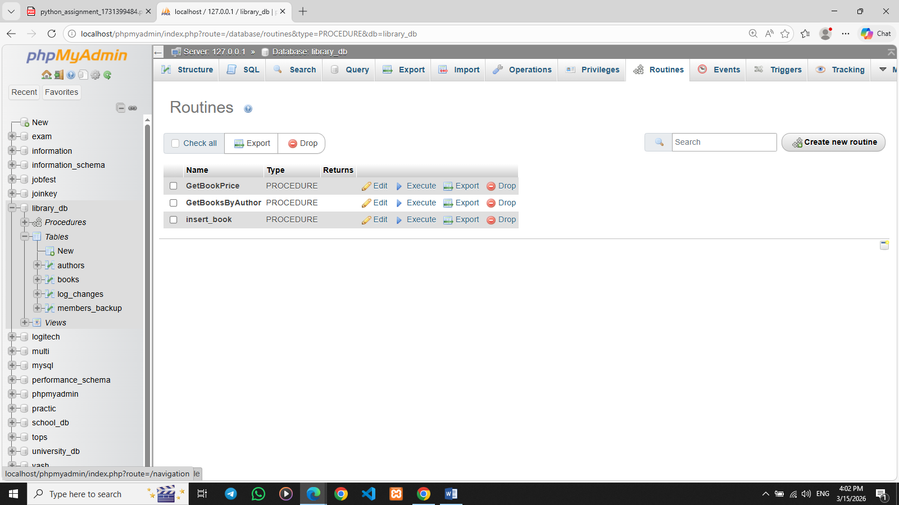

Lab 4: Write a PL/SQL block to display the total number of books in the books table.
Ans. DELIMITER //

CREATE PROCEDURE total_books()
BEGIN
DECLARE book_count INT;

SELECT COUNT(*) INTO book_count
FROM books;

SELECT CONCAT('Total number of books: ', book_count) AS message;
END //

DELIMITER ;
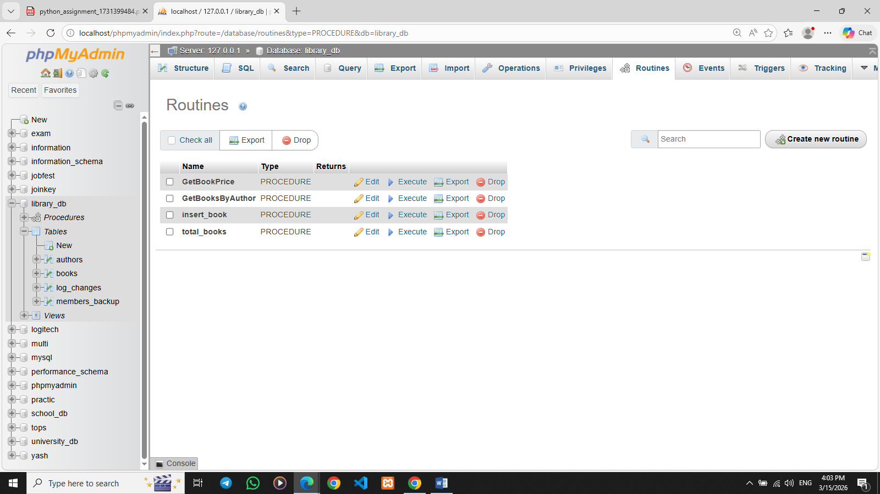

- PL/SQL Syntax

Lab 3: Write a PL/SQL block to declare variables for book_id and price, assign values, and display the results.
Ans. DELIMITER //

CREATE PROCEDURE show_book_variables()
BEGIN
DECLARE v_book_id INT;
DECLARE v_price DECIMAL(10,2);

SET v_book_id = 1;
SET v_price = 60.00;

SELECT v_book_id AS book_id, v_price AS price;
END //

DELIMITER ;
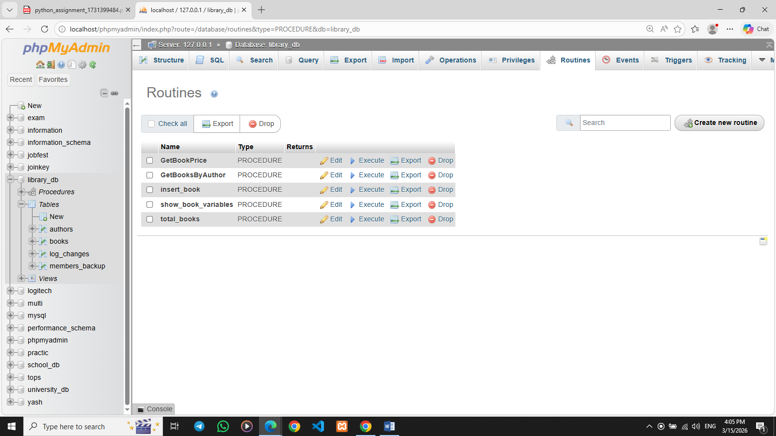

Lab 4: Write a PL/SQL block using constants and perform arithmetic operations on book prices.
Ans. SET @book_price = 60;
SET @tax_rate = 0.10;

SELECT
@book_price AS original_price,
@tax_rate AS tax_rate,
(@book_price * @tax_rate) AS tax_amount,
(@book_price + (@book_price * @tax_rate)) AS final_price;
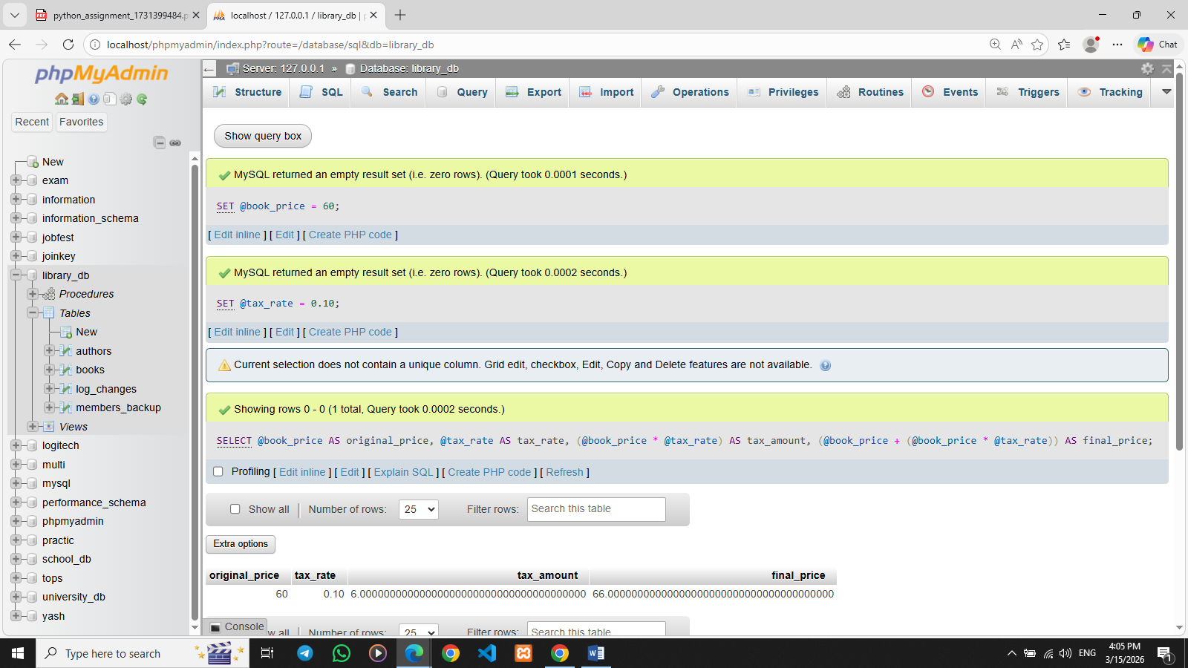

- PL/SQL Control Structures

Lab 3: Write a PL/SQL block using IF-THEN-ELSE to check if a book's price is above $100 and print a message accordingly.
Ans. DELIMITER //

CREATE PROCEDURE check_book_price()
BEGIN
DECLARE v_price DECIMAL(10,2);

SET v_price = 120;

IF v_price > 100 THEN
SELECT 'The book price is above $100' AS message;
ELSE
SELECT 'The book price is $100 or below' AS message;
END IF;

END //

DELIMITER ;
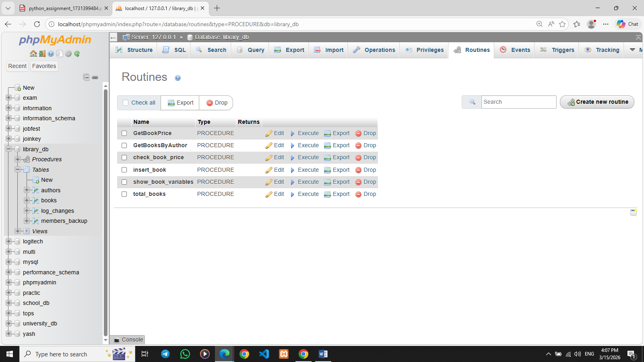

Lab 4: Use a FOR LOOP in PL/SQL to display the details of all books one by one.
Ans. DELIMITER //

CREATE PROCEDURE display_books()
BEGIN
DECLARE done INT DEFAULT FALSE;
DECLARE v_title VARCHAR(100);
DECLARE v_author VARCHAR(100);
DECLARE v_price DECIMAL(10,2);

DECLARE book_cursor CURSOR FOR
SELECT title, author, price FROM books;

DECLARE CONTINUE HANDLER FOR NOT FOUND SET done = TRUE;

OPEN book_cursor;

read_loop: LOOP
FETCH book_cursor INTO v_title, v_author, v_price;

IF done THEN
LEAVE read_loop;
END IF;

SELECT v_title AS title, v_author AS author, v_price AS price;

END LOOP;

CLOSE book_cursor;
END //

DELIMITER ;
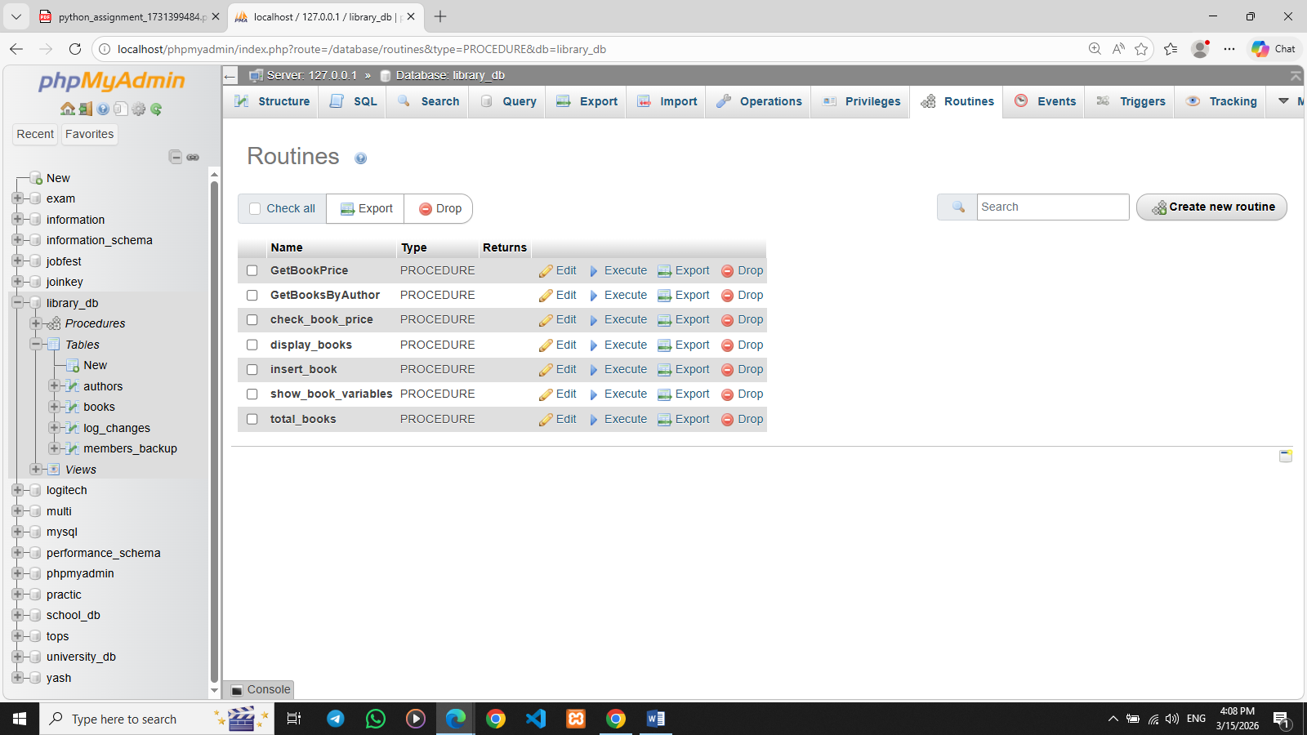

- SQL Cursors

Lab 3: Write a PL/SQL block using an explicit cursor to fetch and display all records from the members table.
Ans. DELIMITER //

CREATE PROCEDURE show_members()
BEGIN
DECLARE done INT DEFAULT 0;
DECLARE v_member_id INT;
DECLARE v_first_name VARCHAR(50);
DECLARE v_last_name VARCHAR(50);
DECLARE v_email VARCHAR(100);

DECLARE member_cursor CURSOR FOR
SELECT member_id, first_name, last_name, email FROM members_backup;

DECLARE CONTINUE HANDLER FOR NOT FOUND SET done = 1;

OPEN member_cursor;

read_loop: LOOP
FETCH member_cursor INTO v_member_id, v_first_name, v_last_name, v_email;

IF done = 1 THEN
LEAVE read_loop;
END IF;

SELECT v_member_id AS member_id,
v_first_name AS first_name,
v_last_name AS last_name,
v_email AS email;
END LOOP;

CLOSE member_cursor;
END //

DELIMITER ;
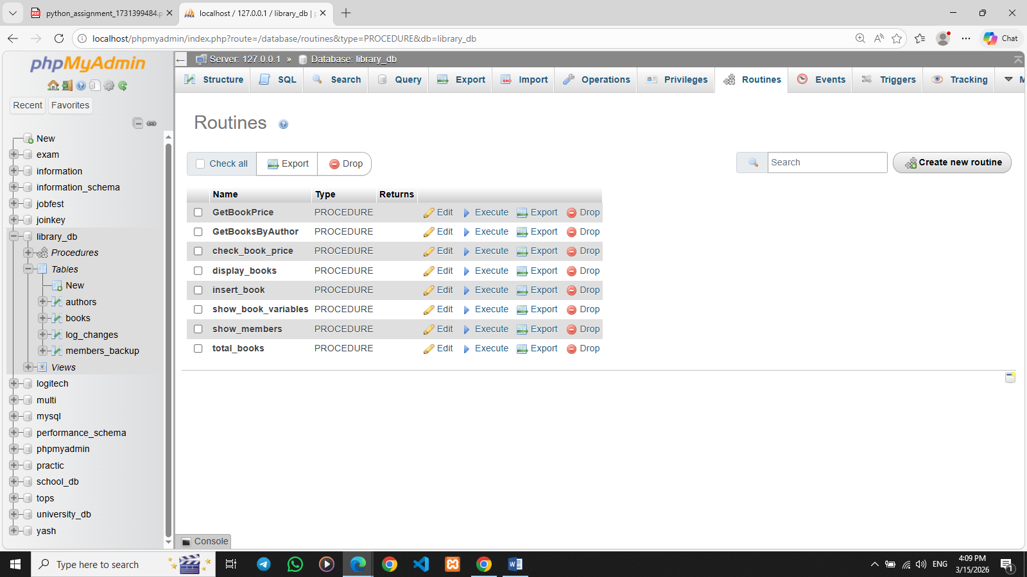

Lab 4: Create a cursor to retrieve books by a particular author and display their titles.
Ans. DELIMITER //

CREATE PROCEDURE books_by_author(IN author_name VARCHAR(100))
BEGIN
DECLARE done INT DEFAULT 0;
DECLARE v_title VARCHAR(100);

DECLARE book_cursor CURSOR FOR
SELECT title FROM books WHERE author = author_name;

DECLARE CONTINUE HANDLER FOR NOT FOUND SET done = 1;

OPEN book_cursor;

read_loop: LOOP
FETCH book_cursor INTO v_title;

IF done = 1 THEN
LEAVE read_loop;
END IF;

SELECT v_title AS book_title;
END LOOP;

CLOSE book_cursor;
END //

DELIMITER ;

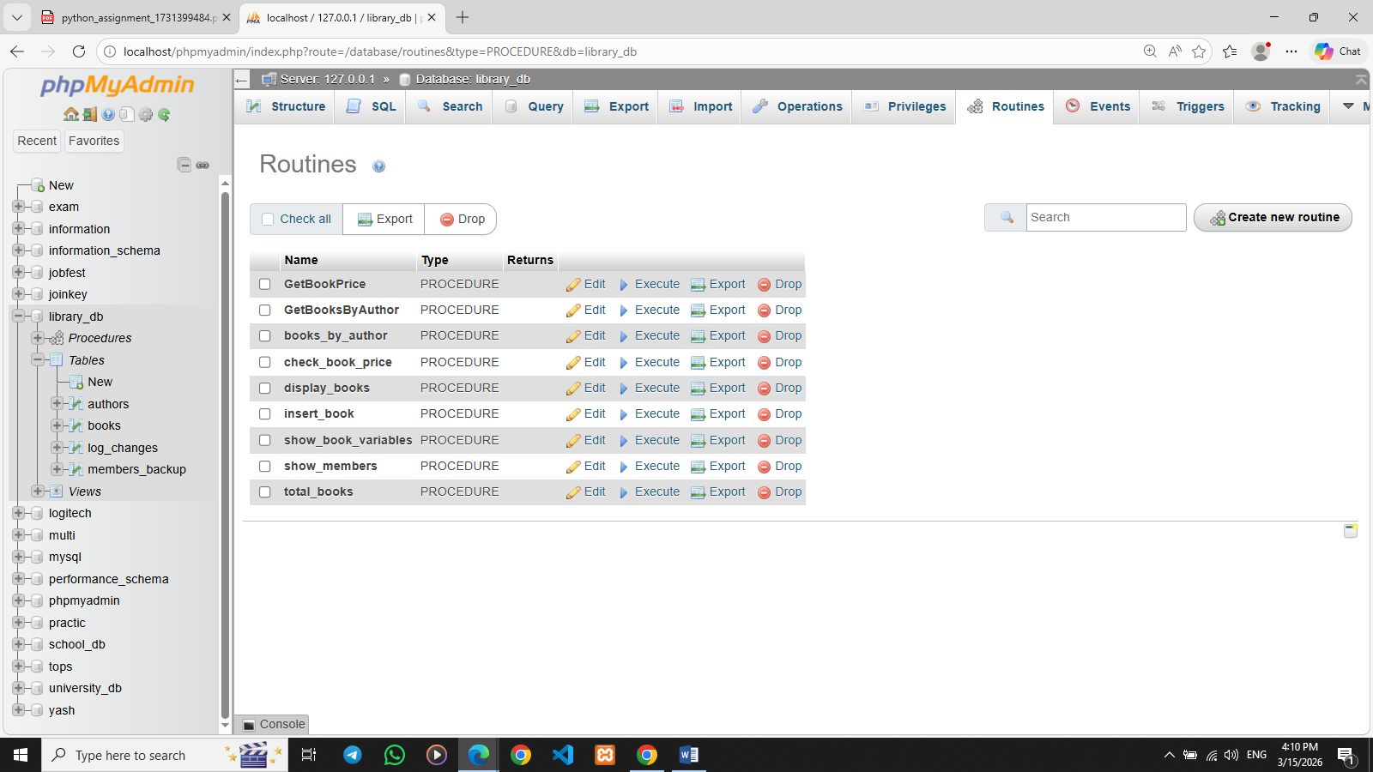
- Rollback and Commit Savepoint

Lab 3: Perform a transaction that includes inserting a new member, setting a SAVEPOINT, and rolling back to the savepoint after making updates.
Ans. START TRANSACTION;
INSERT INTO members_backup (member_id, member_name, date_of_membership, email)
VALUES (6, 'Amit Patel', '2024-01-10', 'amit@gmail.com');
SAVEPOINT sp1;

UPDATE members_backup
SET email = 'amit_new@gmail.com'
WHERE member_id = 6;

ROLLBACK TO sp1;

COMMIT;
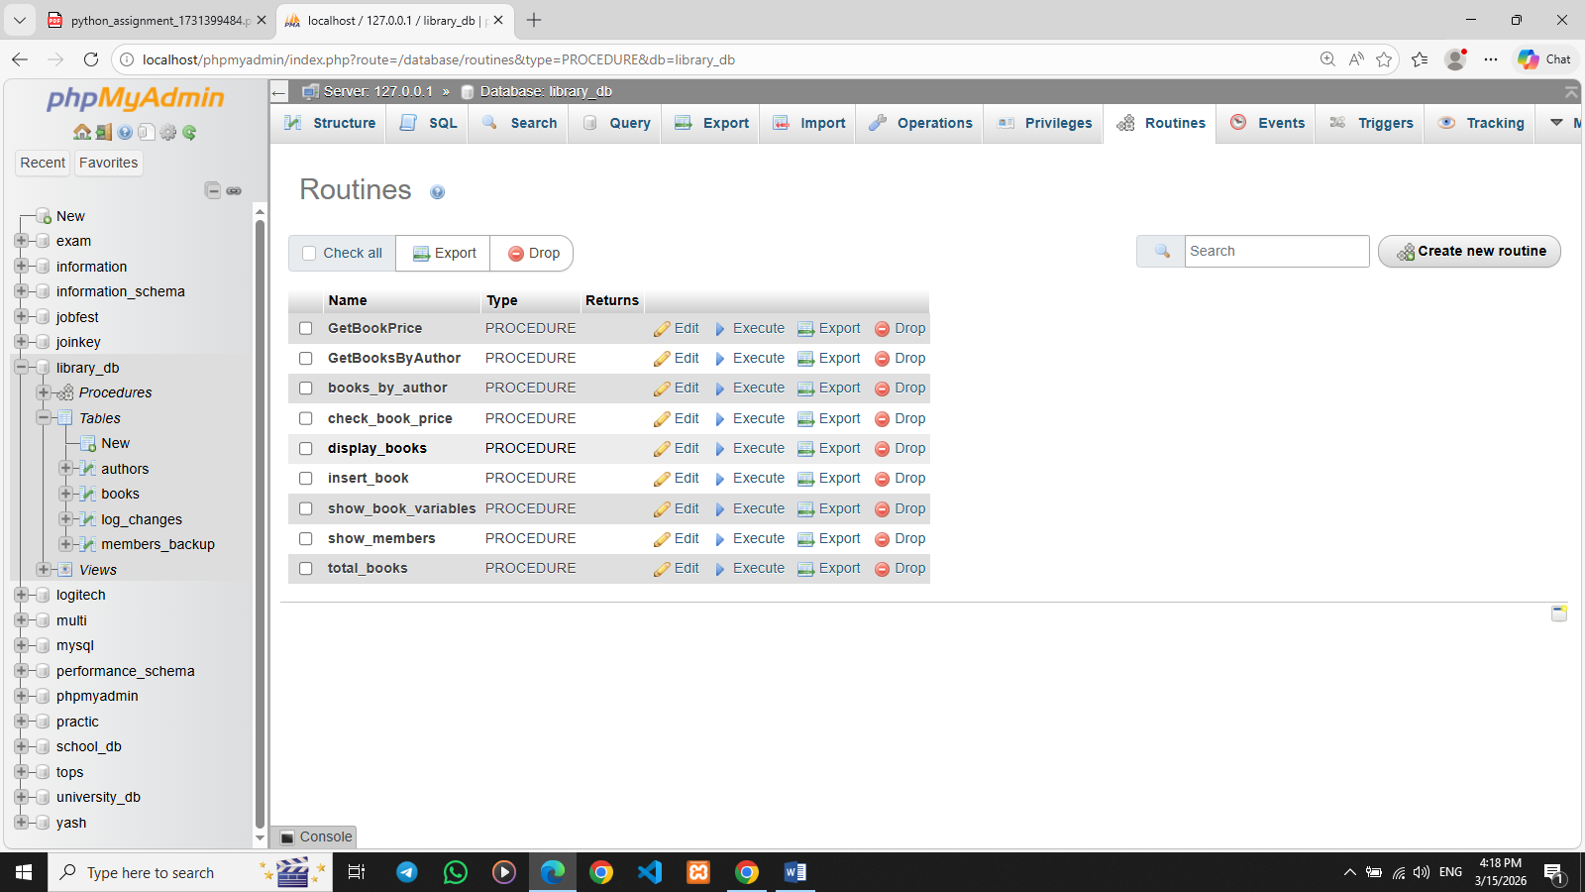

Lab 4: Use COMMIT after successfully inserting multiple books into the books table, then use ROLLBACK to undo a set of changes made after a savepoint.
Ans.
START TRANSACTION;
INSERT INTO books (book_id, title, author, publisher, year_of_publication, price, genre)
VALUES
(4, 'MySQL Guide', 'Rahul Mehta', 'TechPress', 2022, 65.00, 'Database'),
(5, 'Learning Python', 'Mark Lutz', 'OReilly', 2021, 80.00, 'Programming');

COMMIT;

START TRANSACTION;

SAVEPOINT sp1;

UPDATE books
SET price = 90.00
WHERE book_id = 3;

DELETE FROM books
WHERE book_id = 2;

ROLLBACK TO sp1;

COMMIT;
